

**Student Handbook**

**2025-2026**

**1450 EAST “G” STREET Ontario, CA 91764 (909) 986-5838**

ADMINISTRATIVE SUPPORT TEAM

Principal: Dr. Alicia Tuttle

Assistant Principal: Nicole Cabase

Assistant Principal: Victoria Mesen

School Counselor: Hubaldo Puebla

Outreach Consultant: Laila Murhi

Outreach Consultant: Jessica Rios

OFFICE SUPPORT TEAM

Office Manager: Judith Gomez

School Office Assistant: Sandra Estrada

Attendance & Records: Yarizeth Hernandez

PAWS Center: Antonio Valdivia

Health Aide: Tiffany Gonzalez

**Una versión en español de esta guía puede ser obtenida poniéndose en contacto con la oficina al (909) 986-5838**

STUDENT SCHEDULE

_____________________________________ ______ ______________

Student Name Grade ID#

**Login Name:** ________________ **Locker #:** ___________  **Locker Serial #:** ________________

| **Student Schedule** | | | |
| --- | --- | --- | --- |
| **Period** | **Subject/Class** | **Room** | **Teacher** |
|  |  |  |  |
|  |  |  |  |
|  |  |  |  |
|  |  |  |  |
|  |  |  |  |
|  |  |  |  |
|  |  |  |  |
|  |  |  |  |

**Parent Acknowledgement of Planner**

I have reviewed Wiltsey’s policies and procedures with my student and will ensure that he/she abides by the rules and regulations presented within.

____________________________________ ________________________

**(Parent Signature) (Date)**

***Wiltsey Middle School Map***

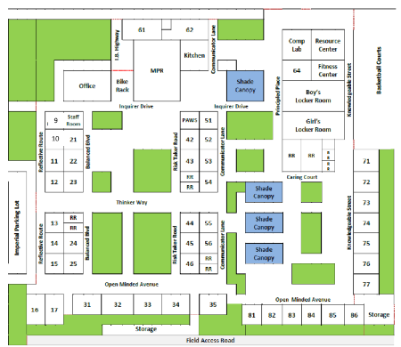

***2025-2026 Calendar***

| **08/27/25** | **Back To School Night** | **2/16/26** | **Presidents’ Day, No School** |
| --- | --- | --- | --- |
| **9/1/25** | **Labor Day, No School** | **3/2/26-3/6/26** | **Student Let Conferences** |
| **9/29/25 - 10/3/25** | **Student Led Conferences** | **3/25/26** | **Open House** |
| **11/10/25-11/11/2025** | **Veterans Day, No School** | **3/30/26 - 4/3/26** | **Spring Break, No School** |
| **11/24/25 - 11/28/25** | **Thanksgiving Break, No School** | **4/20/26- 5/8/26** | **State Testing** |
| **10/6/25** | **Non-School Day, No School** | **5/20/26** | **End of Year Field Trips** |
| **12/22/25 - 1/2/26** | **Winter Break, No School** | **5/19/26** | **8th Grade Promotion Ceremony** |
| **1/19/26** | **MLK Holiday, No School** | **5/21/26** | **Last Day of School** |
| **2/9/26** | **Lincoln’s Birthday, No School** |  |  |

**Ray Wiltsey Middle School**

**Bell Schedule 2025-2026**

**M/W/Th/F**

**8:15 a.m. – 2:30 p.m.**

| **7th** | **Lunch** | **Min.** | **8th** | | **Lunch** | **Min.** | |
| --- | --- | --- | --- | --- | --- | --- | --- |
| **1** | 8:15-9:01 | **46** | **1** | 8:15-9:01 | | | **46** |
| **2** | 9:05-9:51 | **46** | **2** | 9:05-9:51 | | | **46** |
| **3** | 9:55-10:41 | **46** | **3** | 9:55-10:41 | | | **46** |
| **4** | 10:45-11:31 | **46** | **4** | 10:45-11:31 | | | **46** |
| **Lunch** | 11:31-12:01 | **30** | **5** | 11:35-12:21 | | | **46** |
| **5** | 12:05-12:51 | **46** | **Lunch** | 12:21-12:51 | | | **30** |
| **6** | 12:55-1:41 | **46** | **6** | 12:55-1:41 | | | **46** |
| **7** | 1:45-2:30 | **45** | **7** | 1:45-2:30 | | | **45** |
|  |  | **345** |  |  | | | **345** |

**Tuesday**

**8:15 a.m. - 1:15p.m.**

| **7th** | **Lunch** | **Min.** | **8th** | **Lunch** | **Min.** |
| --- | --- | --- | --- | --- | --- |
| **1** | 8:15-8:54 | **37** | **1** | 8:15-8:54 | **39** |
| **2** | 8:58-9:32 | **34** | **2** | 8:58-9:32 | **34** |
| **3** | 9:36-10:10 | **34** | **3** | 9:36-10:10 | **34** |
| **4** | 10:14-10:48 | **34** | **4** | 10:14-10:48 | **34** |
| **Lunch** | 10:48-11:18 | **30** | **5** | 10:52-11:26 | **34** |
| **5** | 11:22-11:56 | **34** | **Lunch** | 11:26- 11:56 | **30** |
| **6** | 12:00- 12:35 | **35** | **6** | 12:00- 12:35 | **35** |
| **7** | 12:39-1:15 | **36** | **7** | 12:39-1:15 | **36** |
|  |  | **270** |  |  | **270** |

**Back to School/Open House/Conferences**

**8:15 a.m. – 1:00 p.m.**

| **7th** | **Lunch** | **Min.** | **8th** | **Lunch** | **Min.** |
| --- | --- | --- | --- | --- | --- |
| **1** | 8:15-8:48 | **33** | **1** | 8:15-8:48 | **33** |
| **2** | 8:52-9:25 | **33** | **2** | 8:52-9:25 | **33** |
| **3** | 9:29-10:02 | **33** | **3** | 9:29-10:02 | **33** |
| **4** | 10:06-10:39 | **33** | **4** | 10:06-10:39 | **33** |
| **Lunch** | 10:39-11:09 | **30** | **5** | 10:43-11:16 | **33** |
| **5** | 11:13-11:46 | **33** | **Lunch** | 11:16- 11:46 | **30** |
| **6** | 11:50-12:23 | **33** | **6** | 11:50-12:23 | **33** |
| **7** | 12:27-1:00 | **33** | **7** | 12:27-1:00 | **33** |
|  |  | **255** |  |  | **255** |

**Last Day of School**

**8:15a.m. -12:00p.m.**

| **7th** | **Lunch** | **Min.** | **8th** | **Lunch** | **Min.** |
| --- | --- | --- | --- | --- | --- |
| **1** | 8:15-8:39 | **24** | **1** | 8:15-8:39 | **24** |
| **2** | 8:43-9:07 | **24** | **2** | 8:43-9:07 | **24** |
| **3** | 9:11-9:35 | **24** | **3** | 9:11-9:35 | **24** |
| **4** | 9:39-10:03 | **24** | **4** | 9:39-10:03 | **24** |
| **5** | 10:07-10:32 | **24** | **5** | 10:07-10:32 | **24** |
| **Lunch** | 10:32-11:02 | **30** | **Lunch** | 10:32- 11:02 | **30** |
| **6** | 11:06-11:31 | **25** | **6** | 11:06-11:31 | **25** |
| **7** | 11:35-12:00 | **25** | **7** | 11:35-12:00 | **25** |
|  |  | **195** |  |  | **195** |

**Student Handbook 2024-2025**

***Table of Contents***

1. **ABOUT WILTSEY**

Growth Mindset---------------------------------------------------------------------------------- pg. 8

1. **SCHOOL SERVICES**

Attendance & Tardy Procedure------------------------------------------------------------------ pg. 8

Breakfast/Lunch Program------------------------------------------------------------------------ pg. 8

School Counseling Services---------------------------------------------------------------------- pg. 9

Emergency Contact Cards------------------------------------------------------------------------ pg. 9

Health Office/Medication------------------------------------------------------------------------ pg. 9

Independent Study Program---------------------------------------------------------------------- pg. 10

1. **POLICIES & PROCEDURES**

Arrival/Dismissal Times-------------------------------------------------------------------------- pg. 10

Bicycles/Skateboards/Scooters----------------------------------------------------------------- pg. 10

Acceptable Use of Technology ------------------------------------------------------------------ pg. 10

Cell Phone & Electronic Device------------------------------------------------------------------- pg. 10

Confiscated Items -------------------------------------------------------------------------------- pg. 10

Physical Education Dress Requirements & Excuses---------------------------------------------- pg. 11

Student Searches--------------------------------------------------------------------------------- pg. 11

Selling Items at School Policy-------------------------------------------------------------------- pg. 11

1. **ACADEMICS**

Awards Recognition Program--------------------------------------------------------------------- pg. 11

Eighth Grade Recognition Night------------------------------------------------------------------ pg. 12

Ineligibility Requirements for Participation in Activities--------------------------------------- pg. 12

Homework Policy----------------------------------------------------------------------------------- pg. 13

Progress Reports & Report Cards----------------------------------------------------------------- pg. 13

Student Led Conferences ------------------------------------------------------------------------ pg. 13

Parent Square--------------------------------------------------------------------------------------- pg. 13

Grade Check--------------------------------------------------------------------------------------- pg. 13

1. **BEHAVIOR EXPECTATIONS**

Behavior Standard-------------------------------------------------------------------------------- pg. 14

Breakfast/Lunchtime Behavior------------------------------------------------------------------- pg. 14

Bullying Behavior---------------------------------------------------------------------------------- pg. 14

Campus Safety------------------------------------------------------------------------------------ pg. 14

Code of Conduct----------------------------------------------------------------------------------- pg. 15

Dress Code “Dress for Success”----------------------------------------------------------------- pg. 15

Graffiti/Tagging Policy--------------------------------------------------------------------------- pg. 16

Parent/Guardian “Shadowing”--------------------------------------------------------------------- pg. 16

Prohibited Items at School---------------------------------------------------------------------- pg.16

1. **STUDENT SERVICES**

Daily Student Bulletin---------------------------------------------------------------------------- pg. 16

Parent/Guardian Participation------------------------------------------------------------------- pg. 16

“PAWS” Counseling Center----------------------------------------------------------------------- pg. 17

Student ID Requirements------------------------------------------------------------------------ pg. 17

Student Planners---------------------------------------------------------------------------------- pg. 17

Textbooks----------------------------------------------------------------------------------------- pg. 17

1. **ACADEMIC HONESTY POLICY**

Integrity ----------------------------------------------------------------------------------------- pg. 17

Violations ----------------------------------------------------------------------------------------- pg. 17

Avoiding Plagiarism & Crediting Sources -------------------------------------------------------- pg. 18

Handling of Academic Dishonesty---------------------------------------------------------------- pg. 19

1. **WILTSEY RESOURCES**

Quick Guide to Parent Square --------------------------------------------------------------------- pg. 20

RI Reading Scores & Goals --------------------------------------------------------------------- pg. 21

RATES Constructed Response Format------------------------------------------------------------ pg. 22

MLA Format --------------------------------------------------------------------------------------- pg. 23

Website Tracker ---------------------------------------------------------------------------------- pg. 24

Healthy Fitness Zones (HFZ) --------------------------------------------------------------------- pg. 25

See Something, Hear Something, and Say Something (English)..................................................... pg. 26

Escuche Algo,Viste Algo, Entonces Algo (Spanish)………………………………………………………………………… pg. 26

PBIS- Wiltsey Middle School Expectations…………………………………………………………………………………pg. 27

School Parent Involvement Policy and Compact …………………………………………… pg. 28

Ontario-Montclair SD Board Policy, Sexual Harassment (English and Spanish)..........................pgs. 29

Ontario-Montclair SD Board Policy, Non Discrimination/Harassment (English and Spanish)pgs. 35

Ontario-Montclair SD Board Policy, Married/Pregnant/Parenting Students (English)...............pg. 34

Ontario-Montclair SD Board Policy, Married/Pregnant/Parenting Students (Spanish)...............pg. 37

# I. ABOUT WILTSEY

**Growth Mindset**

The term ‘growth mindset’ refers to a way of thinking, learning and taking on challenges. A person with a growth mindset is open to constructive criticism, accepts feedback and uses it to improve, takes on new challenges, pushes oneself outside of his/her comfort zone and shows resilience and perseverance. Studies show that it is people with a growth mindset (as opposed to a fixed mindset) who better persevere through challenges, are more successful in overcoming adversity and have a more positive outlook on life. Our aim is to foster this growth mindset in our students so that they can achieve their full potential.

Some key aspect of Growth Mindset at Wiltsey:

* Persevere through challenges.
* Take risks and try different approaches/strategies to solve complex problems or tasks.
* Learn from others. Our peers often make the best teachers.
* Don’t compare yourself to others. You are unique and gifted in your own special way.
* Challenge yourself to see things from another point of view.
* Participate and get involved in your learning.
* Mastering something new gives a sense of accomplishment.
* The brain is making new connections all the time. You can learn anything!

# II. SCHOOL SERVICES

##### Attendance & Tardy Procedures

##### It is very important that students attend school every day to be successful, and Wiltsey strives to be at the top of the district in attendance. The Attendance Office can be reached by calling: (909) 986-5838, ext. 227. Absences for oversleeping, bad weather, babysitting, vacations, transportation, personal or family business, etc. are not considered valid excuses by the State of California for missing school.

**Absences:** Parents/Guardians must call the school attendance office at 986-5838, ext. 227 as soon as they know their student will be absent so the absence can be verified. If unable to call, a written excuse signed by a parent/guardian must be turned in to the Attendance Office on the first day the student returns from the absence. Students returning from an absence, must report to the attendance office and receive a re-admit slip before they attend their first class of the day. Absences will be marked “TRUANT” unless the Attendance Office receives a note or phone call from a parent/guardian within three calendar days after the student is absent. Truancies (unexcused absences) & excessive absences will be referred to the Counselors, Administration, and possibly the District’s School Attendance Review Board (SARB) for further action. Truancies make students ineligible for school dances and other extracurricular activities.

**Tardies:** Students are expected to be in class on time with any necessary supplies (i.e. pencils, paper, etc.) every day before the start of each period. For late arrivals to first period, between 8:15 A.M. to 8:25 A.M., students will report directly to their first period class. If students arrive to first period after 8:25 A.M., they must report to the Attendance Office for a tardy slip. Teachers will not accept students into their first period classes after 8:25 A.M. without a tardy slip. Students arriving after their first period class will also need to get an admit slip from the Attendance Office the next day. Consequences for being tardy may include detention, referral to Administration, loss of privileges, and other appropriate actions that will prevent future tardiness.

**Breakfast/Lunch Program**

The Ontario-Montclair School District takes part in the National School Lunch and Breakfast Program. Nutritious meals are served every school day at Wiltsey, and all students receive breakfast and lunch at no charge. Each student’s ID card will serve as their meal card. Their ID number must be scanned or entered each time the student receives a school breakfast or lunch. Students should memorize this number and not share it with any other students.

**School Counseling Services**

Our school counselor is available to assist students who are having trouble keeping up with their schoolwork, making friends, or adjusting to the middle school experience. Additionally, they assist parents/guardians and students with any questions or concerns about attendance and academics, as well as offering available resources and services. As the result of self-referrals, parent/guardian referrals, and/or teacher referrals, some students may participate in individual or group counseling throughout the school year. Students may stop by the “PAWS Center” to see a counselor anytime during the school day.

#### Emergency Contact Cards

All students and parents/guardians are required to complete an emergency card with three working phone numbers as a requirement for enrollment. Students who do not have a completed emergency card on file may be excluded from school until it is completed and turned in to the school office. Parents/guardians must keep the school’s office informed of any change of address and/or telephone number during the school year.

##### Health Office

The health office is a first aid stationequipped for minor injuries and illnesses. Students who display symptoms of a serious illness such as fevers higher than 100 degrees, chills, vomiting, and breathing problems should see a doctor and stay home until all symptoms have passed. Students who become ill or injured at school may report to the health office with written consent from their teacher or another staff member. If a child is found to be too ill to remain at school, a parent, guardian or emergency contact will be notified to pick up the student. Students are not allowed to leave campus during school hours under any circumstance without permission or use their personal cell phones during school hours to contact a parent regarding their illness (unless they have been given direct permission to do so by staff personnel). The school nurse or health assistant will make all parent/guardian notifications. Inform the school nurse or health assistant of any serious health concerns and/or to report any changes to a student’s emergency card or health information. Make sure to update, and provide a copy to the school, of all changes to immunization records.

**Medication**

If a student requires medication during school hours, a Medication Administration Form must be filled out by a physician and signed by a parent/guardian. This policy also applies to any over the counter medication, such as; Tylenol, aspirin, cough drops, etc. This form should be returned to the Health Office with the prescribed medication. All medications must have a prescription label with the student’s name, birth date, medication name, dose, prescribing doctor and expiration date. All medications will be administered by the school nurse, health assistant, or a trained staff member, according to the doctor’s directions. Any Student who is prescribed an inhaler for Asthma, may self-carry his/her medication, if a signed medication form with permission from the child’s doctor has been received by the school. All medications must be delivered and or picked up at the end of the school year by a parent/guardian. If there are changes in your child’s medication, inform the school and have a new Medical Administration Form completed by the student’s physician. All medications without proper paperwork are prohibited. Please contact the School Nurse or Health Assistant at (909) 986-5838 ex.225 for details or further questions.

**Independent Study Program**

A short–term independent study program is an optional educational alternative to classroom instruction available to students who are absent for as few as one school day. A written independent study agreement must be completed by a parent/guardian and the student. The agreement documents may be obtained from the main office. Requests for an independent study program must be submitted a minimum of five (5) school days in advance of the leave.

Work assignments and needed resources will be determined and provided by the student’s teachers and a due date for the assignments will be established. For attendance purposes, the absence will be marked unexcused until such time that the work is graded and placed on file. If all the conditions of the agreement have been met, including deadlines and satisfactory work performance, the attendance record will be changed so the student receives credit for the days absent.

**III. POLICIES & PROCEDURES**

##### Arrival/Dismissal Times

It is the responsibility of each student to be in class on time and prepared to learn! All students will enter campus through the G Street gate, which opens at 7:45 a.m. daily for all students. The first period bell rings each day at 8:10 a.m. and class starts at 8:15 a.m. School is dismissed at2:30 p.m. on Monday, Wednesday, Thursday and Friday and at 1:15 p.m. on Tuesday. All students are required to leave campus immediately at the end of the school day, unless they are participating in an authorized after school activity.

##### Bicycles, Skateboards & Scooters

Bicycle, skateboard, and scooter racks are provided in the area next to the main office. Bicycles, skateboards, and scooters are not to be ridden or used on school grounds, or while entering and exiting the school. All items are to be locked and secured in the proper area using a personal lock. No “lock-sharing” is allowed. The school is not responsible for damage or theft of these items while locked in the rack area. In traveling to and from school, all traffic laws, city ordinances, and safety rules must be obeyed. Bicycles, skateboards, and scooters will be confiscated if students do not have a helmet in their possession. In order to return the confiscated item, the student must bring a helmet to school.

##### Acceptable Use of Technology

All Wiltsey students and parents must sign an OMSD Acceptable Use of Technology Agreement which establishes policies for responsible student use of technology and related resources. Use of technology including cell phones, iPads, computers and social media to bully or harass students or staff will not be tolerated. Students may not visit web sites without express permission from their teacher. Searches for “inappropriate” sites and images are prohibited. Misuse of equipment, such as etching on it or removing keys, is considered vandalism and will result in disciplinary action and replacement charges.

**Cell Phones & Electronic Devices**

Students may **not** use their cell phones & headphones on campus at all during the school day. Cell phones should be turned off and in the student’s backpack when they enter campus. If a student has a cell phone in their pocket or is using the cell phone while on campus, it will be confiscated and must be picked up by a parent/guardian. Wiltsey reserves the right to investigate and issue consequences to students using their cell phones to bully and/or spread inappropriate content on campus or social media.

**Confiscated Items**

Wiltsey is not responsible for confiscated items. These items include, but are not limited to, balloons, toys, stuffed animals, cell phones, music players, candy, gum, food, hats or any other personal items being used in the classroom or on campus that are not part of the academic learning program. Any prohibited items, or items used in violation of school rules, may be confiscated and are required to be picked up by an authorized parent/guardian. Remember this general rule: If you do not have permission from a school official to bring an item to school, don’t bring it!

#### Physical & Health Education Dress Requirements

Physical & Health Education (PHE) is a required daily class and is extremely important to a student’s physical health and well-being. Students are expected to dress out and participate every day in the PHE program. The PHE Department has a very strict policy regarding dressing out and has specific consequences for failing to do so. Students who do not dress out are still required to participate. Non-dress students will lose points each day they fail to dress out, which will result in a lower effort score and possible detention. Students who forget their clothes will be provided loaner clothes. PHE uniforms must be cleaned weekly. The preferred Physical & Health Education uniform is defined as a Wiltsey t-shirt, Wiltsey shorts, or plain green, gray or black sweatpants and athletic shoes and socks. (Wiltsey shorts, shirts, and sweats are available for purchase from the PHE Department).

#### Physical & Health Education Excuses

If a student is sick or unable to participate in physical exercise for the day, a written note with a working phone number from the parent/guardian is required. A note from the parent/guardian may excuse a student up to three consecutive school days. If a student needs to be excused from his/her PHE class for more than three consecutive school days, a doctor’s note is required.

**Student Searches**

As set forth in OMSD Board Policy 5145.12, Wiltsey Administrators or designee may search any individual student, his/her property, or district property under his/her control when there is a “reasonable suspicion” that the search will uncover evidence that the student is violating the law, OMSD Board Policy, and/or other rules of the district or school. Searches may be conducted without prior approval of parents/guardians. Parents/guardians will be notified as soon as possible after the search. The type of student property that may be searched includes, but is not limited to, clothing, lockers, desks, purses, backpacks, cellular phones, and/or other electronic communication devices.

##### Selling Items at School

The selling of candy, food, or other items by any student or group, without authorization by the school administration, is prohibited.

**IV. ACADEMICS**

**Awards Recognition Program**

Students who achieve excellence in recognized areas throughout the school year will be honored for their accomplishments each month and/or during an awards ceremony at the end of each semester. Honor roll and Principal’s Honor Roll recipients will be presented a spirit chain. Students will collect the spirit chains during their middle school experience and will be allowed to wear them on campus and at their Eighth Grade Promotion Ceremony to demonstrate their commitment to excellence. Students may earn recognition in the following categories:

* **Principal’s Honor Roll:** Awarded each semester to students with a cumulative GPA of 4.0
* **Honor Roll:** Awarded each semester to students with a cumulative GPA of 3.5-3.9
* **Outstanding Wildcat:** Awarded each month to students who consistently demonstrate outstanding academic effort, honesty, integrity, courtesy, respect, and kindness to both adults and peers. Monthly award winners will receive a certificate.
* **Most Improved Wildcat:** Awarded each month to students who demonstrate extraordinary academic and/or behavior improvement during a particular month. Monthly award winners will receive a certificate.
* **ROAR Award:** Awarded each month to deserving students who are exceptional wildcats that exhibit our Four ROAR PBIS Expectations with fidelity. Monthly award winners will receive a certificate.
* **Wildcat Sportsmanship Award:** Awarded each month to students who demonstrate outstanding effort and sportsmanship in Physical & Health Education. Monthly award winners will receive a certificate.
* **iREADY Excellence:** Awarded each semester to deserving students who strive for excellence in achieving their growth goals in iREADY.
* **Rotary Club Student of the Month Award:** Awarded monthly by the Ontario Rotary Club to a deserving eighth grade student. The student will be selected from the list of students who received an Outstanding Wildcat award at any time throughout the year. The student will receive a certificate of achievement at a Rotary Club luncheon where the parents are invited to attend.

**Eighth Grade Recognition Night**

At the end of the year, eighth grade students will be recognized for their outstanding accomplishments in a variety of categories during an evening honors ceremony. Categories may include:

**Principal's Honor Roll Excellence AVID Excellence**

**Honor Roll Excellence Music Excellence**

**Language Arts Excellence Visual Arts Excellence**

**History Excellence Foreign Language Excellence**

**Mathematics Excellence ASB/Leadership Excellence**

**Science Excellence ELD Excellence**

**Ineligibility Guidelines for School Activities**

Wiltsey Middle School provides a wide range of extra-curricular and co-curricular opportunities for students to participate in throughout the year. Participation in these activities is a “privilege,” not a “right.” Minimum requirements have been established for students to participate in these school activities, events, and sports. Students will be deemed ineligible if they meet one or more of the following criteria. Note that the Administrative Team may use discretion on a case by case basis.

**Social Events**

* No Administrative suspension incidents between events
* No “U’s” in Behavior or in Effort on most recent Progress Report/Card
* 5 or more class tardies between events
* Unresolved fines or fees

**Sport Teams**

* No Administrative suspensions during the sports season (The sports season is from the date of tryouts)
* No “U’s” in Behavior or in Effort on most recent Progress Report/Card
* No ‘F’s” in any class

**Eighth Grade Promotion Ceremony**

* No more than two (2) F grades in the second semester
* No more than three (3) incidents of suspension from school
* No more than six (6) total days of suspension, either in-school or out-of-school for the 8th grade year
* Must not be on suspension from school on the day of the promotion ceremony

**End-of-the Year Activities**

* No “U” in any class at the time of the event
* No grade of F in any class at the time of the event
* Must not be suspended (on or off campus) after February 1st.
* Must not have more than 2 hours of unserved detention pertaining to tardiness/truancies (30 min per. tardy-2nd semester)

##### Homework Policy

The OMSD School Board acknowledges the educational validity of homework as an extension of the instructional program of the school. Homework is defined as school-related assignments by a teacher or through mutual agreement of the student and teacher, which will require time and effort outside of the regular classroom for successful completion. Daily homework assignments should normally include an average 90 minutes, 4-5 days per week.

**Progress Reports & Report Cards**

Students will receive progress reports for their classes every nine weeks between report cards. A school-wide parent/guardian phone notification is made the day the progress report is sent home with your student so that parents/guardians will be expecting them.

**Parent Conferences**

Student Led Conferences take place at the middle of each semester. During the conference, students reflect and take ownership of their learning. Parents are strongly encouraged to participate in person to support their students’ academic growth. During the student-led conference, parents and students jointly

**Grade Check**

At the end of each month Wiltsey will complete grade checks. If students pass the grade checks they will develop goals that will be reflected on at the next student-led conference. be invited to an extra-curricular event honoring their hard work and dedication towards academics. Students will be presented with these requirements at the beginning of the year during the PAWSitive Expectations Assembly, as well as, reminded each month.

**SARC Report**

The SARC report is the School Accountability Report Card. It is available online or, if you would prefer a hard copy, in the front office.

**V. BEHAVIOR EXPECTATIONS**

**Behavior Standard**

The Progressive Discipline Program at Wiltsey is informed by the evidence-based practices of Positive Behavior Intervention Systems (PBIS) with the belief that discipline is not intended to punish students, but to reinforce and teach appropriate habits and behavior that they will need in high school and their adult lives. The discipline program is based on the following behavior standards:

* All students matter and have value
* Behavior is a matter of choice
* All students are able to behave appropriately and must accept responsibility for their own behavior
* Students may not prevent a teacher from teaching or another student from learning
* Parents/Guardians have a right and obligation to participate in and support the school’s discipline program

**PBIS Expectations**

*All Students at Ray Wiltsey Middle School are expected to:*

* Be Safe
* Be Respectful
* Be Responsible
* Be Ready to Learn

**Breakfast/Lunchtime Behavior**

Students are to eat only in designated areas. The specific breakfast/lunchtime rules are as follows:

* All food or beverages must remain in the designated eating areas. No food or beverages are allowed on the athletic field or courts.
* Students are expected to be polite to and follow the directions of all campus supervisors.
* Students must clean up after themselves. Everyone is responsible for disposing of his/her own trash into the appropriate trash and recycling containers.
* Students must have a lunch pass (with a date & signature on it) from their teacher or club sponsor in order to visit a classroom during lunchtime.
* The East Quad restrooms are the only restrooms available for use during lunchtime.

**Bullying Behavior**

Wiltsey Middle School does not tolerate physical and/or emotional abuse. Bullying behavior includes, but is not limited to: embarrassing, teasing, pushing, hitting, name-calling, intimidating, harassing, threatening, sexual harassment, exclusion of others, and cyber-bullying. “Cyber-Bullying” is bullying through an electronic source such as email, texting or content posted on the internet. Students who are a victim of bullying are urged to inform one of their teachers, counselor, and/or a school administrator immediately. Parents who suspect their child is being bullied should contact a school administrator or counselor. The situation will be handled discreetly and confidentially.

**Campus Safety**

Wiltsey staff and students strive to maintain a physically and emotionally safe learning environment for all. In order to ensure our campus remains safe at all times, there are some school-wide expectations for all students. Students will:

* Keep their hands and feet to themselves. This means activities such as: pushing, shoving, grabbing, kicking, play-fighting, roughhousing or inappropriate displays of affection (such as holding hands, hugging and kissing) are prohibited.
* Use passing periods for going to and from classes, restrooms, and/or use of drinking fountains.
* Keep conversations at a normal speaking voice when outside. Students will refrain from yelling or whistling.
* Walk at all times while on-campus.
* Students are expected to use the sidewalks and are not to walk across the parking lots.
* Once campus gates are opened, students must enter campus immediately. Students may not loiter in front of the school.

**Code of Conduct**

Proper behavior is expected at all times while at school, on the way to and from school, and during any school sponsored event. The following is a list of examples of proper behavior. If something is not specifically mentioned, remember the rule – “Behavior should be proper and appropriate at all times.” If you don’t know if particular behavior is proper or appropriate please ask a school official.

* All Education Code (48900/48915) & Board Policy (5144.1) “Rules & Regulations” are to be followed at all times*
* Be on time to school and classes
* Be prepared with the materials identified by teachers as necessary for each day’s assignments
* Treat everyone (parents/guardians, staff, students, guests, substitutes) in a courteous and respectful manner with appropriate language
* When given directions by an adult, address them immediately
* Complete class work and homework assignments, including make-up assignments missed due to absences
* Never copy another student’s work or take credit for work that is not yours
* Respect the rights and property of others
* Never take anything that isn’t yours without permission, even if you “found it.” Items found on campus should be turned in to the office, PAWS Center or a teacher.

**Dress Code “Dress for Success”**

Although Wiltsey students do not wear uniforms, they are expected to follow Wiltsey’s guidelines for dress & grooming. Students are expected to “Dress for Success,” as school is where students prepare themselves for career and community success. Violations of dress code will result in a change, or fixing, of clothing at school, or a phone call home to request a change of clothing.Repeat violations may result in detention and/or school suspension for defiance of school rules.

**General Rules**

* All clothing must be safe, non-distracting and non-disruptive to the learning process.
* Clothes are expected to be worn correctly covering all undergarments at all times.
* Hats and Beanies must be solid colors including black, green & white, or a Wiltsey Logo hat.
* Students may be asked to remove jewelry that is considered to be unsafe orinappropriate, such as sharp/spiked jewelry, stretchers, piercings, or items that are worn in a place on the student’ body that may be unsafe.
* PE clothes are to be worn during PE class only.
* Shoes must be worn at all times.
* Open toe shoes are permitted, but must have a back strap.
* All Shoes must have a backstrap or enclosed back.
* Clothing and accessories should be free of writing, pictures, or any other insignia or design which is crude, vulgar, profane, or sexually suggestive; or which displays drug, alcohol, tobacco and/or weapon references; or which advocate racial, ethnic, or religious prejudice, or criminal activity.
* All gang related accessories and attire are prohibited (The term “Gang” refers to any unauthorized group, crew or clique).
* Shorts, skirts and dresses should be fingertip-length, with arms held at the side.
* Necklines should be no lower than four fingers from the collar bone.
* Tops should conceal undergarments and skin, and cover the back and midriff completely.
* Sheer (see-through) clothing should only be worn with appropriate clothing underneath.
* Excessively tight/revealing clothes are inappropriate for school.
* Pants should be worn around the waist and fit appropriately. No sagging or belting below the waist.

**Graffiti/Tagging**

Wiltsey Middle School has a zero tolerance policy for tagging activity. Anyone involved in tagging will receive disciplinary action which may include suspension and a citation from the Ontario Police Department. Tagging activity is not allowed at any time, this includes possession of tagged documents, notebooks, or any personal property and/or possession of tagging instruments including, but not limited to, paint, spray cans, permanent markers, paint pens, white out, etching or scratching tools and stickers. Tagging materials will be confiscated and not returned, and may be turned over to law enforcement.

**Parent/Guardian “Shadowing”**

OMSD Board Policy (BP 5114 a-b) stipulates that "whenever a student has been suspended from class for committing an obscene act, engaging in habitual profanity or vulgarity, disrupting school activities, or willfully defying valid staff authority, the teacher of the class from which the student was suspended may require the student's parent/guardian to attend a portion of a school day inthat class." This “shadowing” applies only to a parent or guardian who is actually living with the student.

**Prohibited Items at School**

If an item is not needed specifically for school, do not bring it unless you have permission from a school official. The following is a list of examples of items that must never be brought to school:

* Explosive devices, firecrackers, M-80’s, cherry bombs, etc.
* Drugs, alcoholic beverages, cigarettes, vapor pens, tobacco products, cigarette papers, lighters, pipes, matches, drug look-alikes, aerosol spray cans and paraphernalia, which include any item used to facilitate drug use
* Weapons, guns, knives, screw drivers, and/or other dangerous objects
* Toys which are realistic simulations of guns and knives, including AirSoft, BB, & pellet guns
* Any type of controlled substance including over the counter medicine and prescriptions
* Gum
* Any food or drink items purchased or prepared off campus for distribution among students, including but not limited to: cupcakes, cakes, pastries, and candy
* Sharpies of sharpie like markers.

**VI. STUDENT SERVICES**

**Daily Student Bulletin**

The daily student bulletin is read each morning. The student bulletin contains notices, announcements, information, and Words of Wisdom that are important to the daily school program.

##### Parent/Guardian Participation

Parents/guardians are encouraged to be involved with their student’s education at Wiltsey. We welcome parent/guardian visits and phone calls. Parents/guardians are welcome to visit their son/daughter's classes throughout the school year. Parents should sign in at the front office, and receive a “visitor’s pass” before they are allowed to visit a classroom. Parents/guardians are encouraged to attend Student Led Parent Conferences, Back-to-School Night, Open House, and Family Nights. Parents/guardians are invited to become involved with Wiltsey’s School Site Council and SELPAC (Site English Learner Advisory Committee), AVID Parent Group, Coffee with Admin and more. These are important parent groups that provide valuable input into our many school programs, our school plan and ongoing educational programs.

**PAWS (Positive Academic & Well-being Support) Center**

Students and parents are encouraged to work collaboratively with the PAWS Center and our School Counselor, Mr. Puebla. A School Counselor plays an integral part in the education of all students by focusing on academic, personal/social and career developmental tasks so they achieve success in school and are prepared to lead fulfilling lives as responsible members of society. Counseling and other related services are available to all students and their parents/guardians. The PAWS Center is open from 7:45 a.m. to 3:00 p.m. (Later times are available by appointment.)

**Student ID Requirements**

Students will be issued an ID card at the beginning of the school year. The ID card must be presented to purchase tickets and participate in school events. The barcode on the card is also used for accounting purposes every time a student receives a meal from the cafeteria. ID’s should only be used by the owner and should not be shared with others. Use of another person’s ID will result in disciplinary action. Altering the ID card in any way is prohibited. SB- 972-This is legislation that requires the suicide hotline information to be on the back of each I.D. card for students in grades 7-12. The telephone number for the National Suicide Prevention Lifeline is 1-800-273-8255. The Crisis Text Line can be accessed by texting HOME to 741741.

**Student Planners**

Every student will be issued a student planner at no charge at the beginning of the school year or when the student first enrolls at Wiltsey. The Student Planner must be brought to school every day. Homework assignments must be recorded in the planner daily. With guidance from the teacher, students will map out important deadlines. If a student planner is lost, stolen, or damaged, please come by the PAWS Center immediately for a replacement.

##### Textbooks

A set of all required textbooks are loaned to students for their use at home during the school year, and are the responsibility of the student. Textbooks are very expensive and are to be used for reference, class work, and homework. They are to be handled carefully, and are not to be written in. Parents/guardians are responsible for the replacement cost of lost, stolen, or damaged books. Promotion certificates and other records will be withheld, and students will be excluded from all extra-curricular activities until the debt is paid in full.

**VII. ACADEMIC HONESTY POLICY**

**Academic Integrity**

Academic success builds on the principle that excellence requires freedom. Honesty and integrity are prerequisites of this freedom. Academic honesty in the advancement of knowledge requires that all students and teachers respect the integrity of one another’s work and recognize the importance of acknowledging and safeguarding intellectual property.

As members of an academic community, students and faculty assume certain responsibilities. One of these responsibilities is to engage in honest communication. Academic dishonesty is a serious violation of the trust upon which an academic community depends. This Academic Honesty Policy is both an articulation of the kinds of behaviors that violate this trust.

**Violations of Academic Honesty**

There are many different forms of academic dishonesty. The following kinds of honesty violations and their definitions are not meant to be exhaustive. Rather, they are intended to serve as examples of unacceptable academic conduct.

Cheating: Using unauthorized notes or other study aids during an examination; using unauthorized technology during an examination; improper storage of prohibited notes, course materials and study aids during an exam such that they are accessible or possible to view; looking at other students’ work during an exam or in an assignment where collaboration is not allowed; attempting to communicate with other students in order to get help during an exam or in an assignment where collaboration is not allowed; obtaining an examination prior to its administration; altering graded work and submitting it for regrading; allowing another person to do one’s work and submitting it as one’s own; submitting work done in one class for credit in another without the instructor’s permission; obstructing or interfering with another student’s academic work; undertaking any activity intended to obtain an unfair advantage over other students.

Plagiarism**:** The representation of another person’s work as one’s own, or the attempt to blur the line between one’s own ideas or words and those borrowed from another source. It is the use of an idea, phrase, or other materials from a written or spoken source without acknowledgment in a work for which the student claims authorship. A student can avoid the risk of plagiarism in written work or oral presentations by clearly indicating, either in footnotes or in the paper or presentation itself, the source of any idea or wording that he or she did not produce. Sources must be given regardless of whether the idea, phrase or other material is quoted directly, paraphrased or summarized in the student-writer’s own words.

Fabrication: Falsifying or inventing any information, citation, or data; using improper methods of collecting or generating data and presenting them as legitimate; perpetrating hoaxes unbecoming to students in good standing or potentially damaging to Wiltsey Middle School’s reputation or that of the members of its academic community of students.

Facilitating Academic Dishonesty: Aiding another person in an act that violates the standards of academic honesty; allowing other students to look at one’s own work during an exam or in an assignment where collaboration is not allowed; providing information, material, or assistance to another person knowing that it may be used in violation of course, or school academic honesty policies; providing false information in connection with any academic honesty inquiry.

Falsifying Records and Official Documents: Forging signatures or falsifying information on official documents

sent home for a parent’s signature.

**Avoiding Plagiarism & Crediting Sources**

Ray Wiltsey Middle School may submit random or selected pieces of work to Turnitin.com or another plagiarism program approved by administration for verification and evaluation of sources. Students should be able to submit electronic copies of any work to either the teacher or the relevant curriculum coordinator for such verification at any time. It is recommended that students keep all rough notes and drafts that they produce in preparing work for submission to teachers or examiners in order to be able to defend themselves against charges of malpractice.

Presenting someone else’s ideas, research, or opinion as your own – even if you have phrased it in different words – is plagiarism, the equivalent of academic stealing, or fraud. Do not use the ideas or research of others in place of your own. Read from several sources to draw your own conclusions and form your own opinions. Incorporate ideas and research of others to support your points. Credit the source of the following types of support:

* Statistics
* Direct quotations
* Indirectly quoted statements of opinions
* Conclusions presented by an expert
* Facts available in only one or two sources

When you credit a source, you acknowledge where you found your information and you give your readers the details necessary for locating the source themselves. Wiltsey has adopted MLA format to appropriately cite all resources in one’s work. To find out more information on how to appropriately cite sources using MLA format please reference page 22 in the planner.

Ignorance of these standards will not be considered a valid excuse or defense. If a student is ever in doubt about an issue of academic honesty, or has any hesitation about a contemplated course of action, the student should consult with his or her teacher or seek the advice of a school counselor.

**Accelerated Reader**

**August 2025**

| **STAR Lexile** | **Reading Range** | **Point Goal** | **Next Lexile Goal** |
| --- | --- | --- | --- |
|  |  |  |  |

**PARENT SIGNATURE __________________________________________________________ Date _________________**

**January 2026**

| **STAR Lexile** | **Reading Range** | **Point Goal** | **Next Lexile Goal** |
| --- | --- | --- | --- |
|  |  |  |  |

**PARENT SIGNATURE __________________________________________________________ Date _________________**

**Books I Want to Read**

(Check each book off after you read it and take an AR test on it)

* ______________________________________________________________________
* ______________________________________________________________________
* ______________________________________________________________________
* ______________________________________________________________________
* ______________________________________________________________________
* ______________________________________________________________________
* ______________________________________________________________________
* ______________________________________________________________________
* ______________________________________________________________________
* ______________________________________________________________________
* ______________________________________________________________________
* ______________________________________________________________________
* ______________________________________________________________________

**AR Point Clubs**

15 points 75 points 150 points 225 points

25 points 100 points 175 points 250 points

50 points 125 points 200 points

**Short Constructed Response Format**

**Example Prompt: What can community members do to help recycle?**

**R:** There are many ways to help recycle.

**A:** Something easy that community members can begin doing is to sort their recyclable materials.

**Te:** According to recycleworks.org, the most beneficial thing community members can do to help the environment is to sort their everyday materials into the following categories: paper, glass, cans, plastic, and compostable. After these materials have been sorted, they can be taken to a local recycling center. Often, community members are paid in exchange for their recyclables which makes recycling all that more appealing.

**S:** Most importantly, recycling has the power to **change** our environment for the better because it creates a cleaner

and   more sustainable world for our future generations.

| **Transitions** | **MLA Introduction** | **Verb Signal Phrases** | | |
| --- | --- | --- | --- | --- |
| In particular  In detail  For example  For instance  To demonstrate  To emphasize  Important to realize  A key point  Most compelling evidence  According to | Name the Author(s)  List the Title of text | Acknowledges | Contends | Points Out |
| Argues | Claims | Refutes |
| Asserts | Illustrates | Reports |
| Notes | Notes | Suggests |
| Believes | Observes | Writes |

**3 BIG QUESTIONS: NON-FICTION**

| **WHAT SURPRISED YOU?** | **WHAT DID THE AUTHOR THINK YOU ALREADY KNEW?** | **WHAT CONFIRMED, CHALLENGED OR CHANGED WHAT YOU KNOW?** |
| --- | --- | --- |
| ! | IDK | ☺ |
| I was surprised when…  I never thought…  I couldn’t believe…  Really? | I didn’t know…  I was confused by…  The author thought I knew… | At first I thought…but…  I was right/wrong about…  My understanding changed when… |

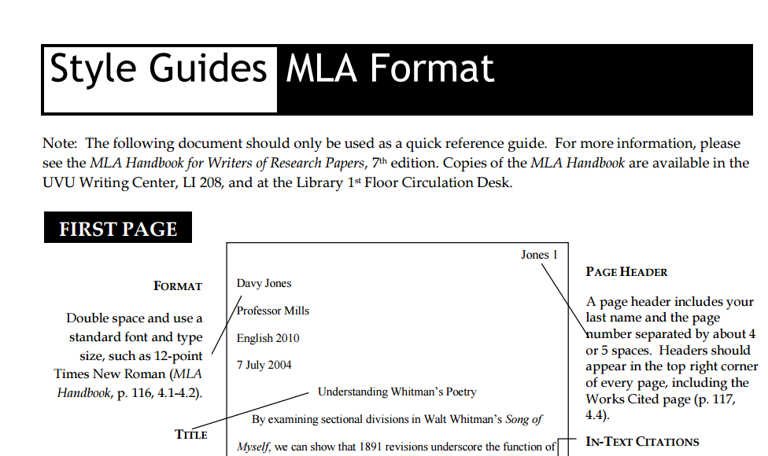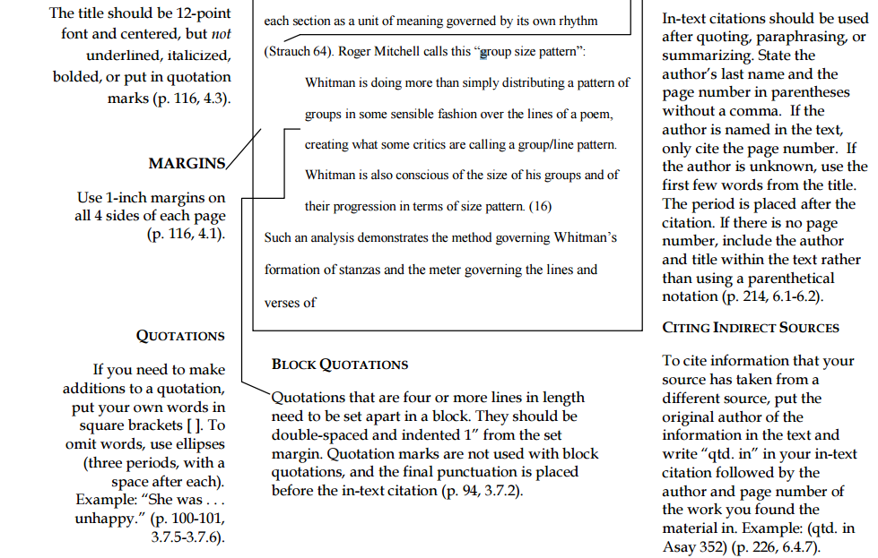

**WEBSITE TRACKER**

| Class: | | Class: | |
| --- | --- | --- | --- |
| Website: | | Website: | |
| Comments: | | Comments: | |
| Login: | Password: | Login: | Password: |

| Class: | | Class: | |
| --- | --- | --- | --- |
| Website: | | Website: | |
| Comments: | | Comments: | |
| Login: | Password: | Login: | Password: |

| Class: | | Class: | |
| --- | --- | --- | --- |
| Website: | | Website: | |
| Comments: | | Comments: | |
| Login: | Password: | Login: | Password: |

| Class: | | Class: | |
| --- | --- | --- | --- |
| Website: | | Website: | |
| Comments: | | Comments: | |
| Login: | Password: | Login: | Password: |

| Class: | | Class: | |
| --- | --- | --- | --- |
| Website: | | Website: | |
| Comments: | | Comments: | |
| Login: | Password: | Login: | Password: |

**Physical Fitness Test**

**Healthy Fitness Zones (HFZ)**

| **Age** | **Curl-up** | **Push-up** | **Trunk Lift** | **1600 Meter** | **Shoulder Stretch** |
| --- | --- | --- | --- | --- | --- |
| 11 | >15 | >8 | 9-12” | 8:30-11:00 | Touching fingertips together behind the back on **both** the right and left sides. |
| 12 | >18 | >10 | 9-12” | 8:00 -10:30 |
| 13 | >21 | >12 | 9-12” | 7:30-10:00 |
| 14 | >24 | >14 | 9-12” | 7:00-9:30 |
| 15 | >24 | >16 | 9-12” | 7:00-9:00 |

| **Age** | **Curl-up** | **Push-up** | **Trunk Lift** | **1600 Meter** | **Shoulder Stretch** |
| --- | --- | --- | --- | --- | --- |
| 11 | >15 | >7 | 9-12” | 9:00- 12:00 | Touching fingertips together behind the back on **both** the right and left sides. |
| 12 | >18 | >7 | 9-12” | 9:00-12:00 |
| 13 | >18 | >7 | 9-12” | 9:00-11:30 |
| 14 | >18 | >7 | 9-12” | 9:30- 11:00 |
| 15 | >18 | >7 | 9-12” | 8:00-10:30 |

**Students will also take a body composition test based on their height and weight. More information about the California State physical fitness tests can be found at** <http://www.cde.ca.gov/ta/tg/pf/>**.**

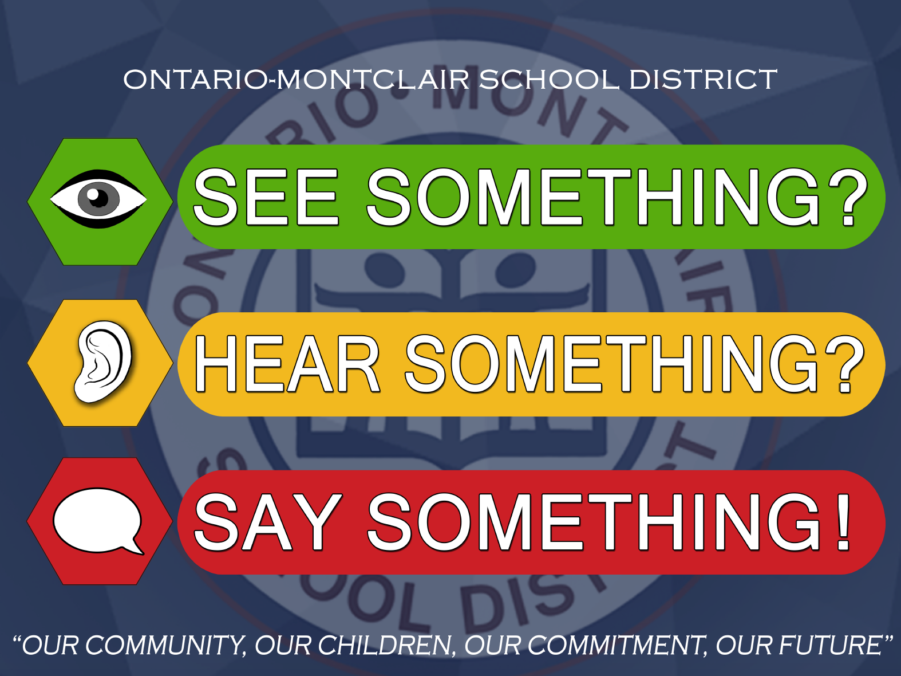

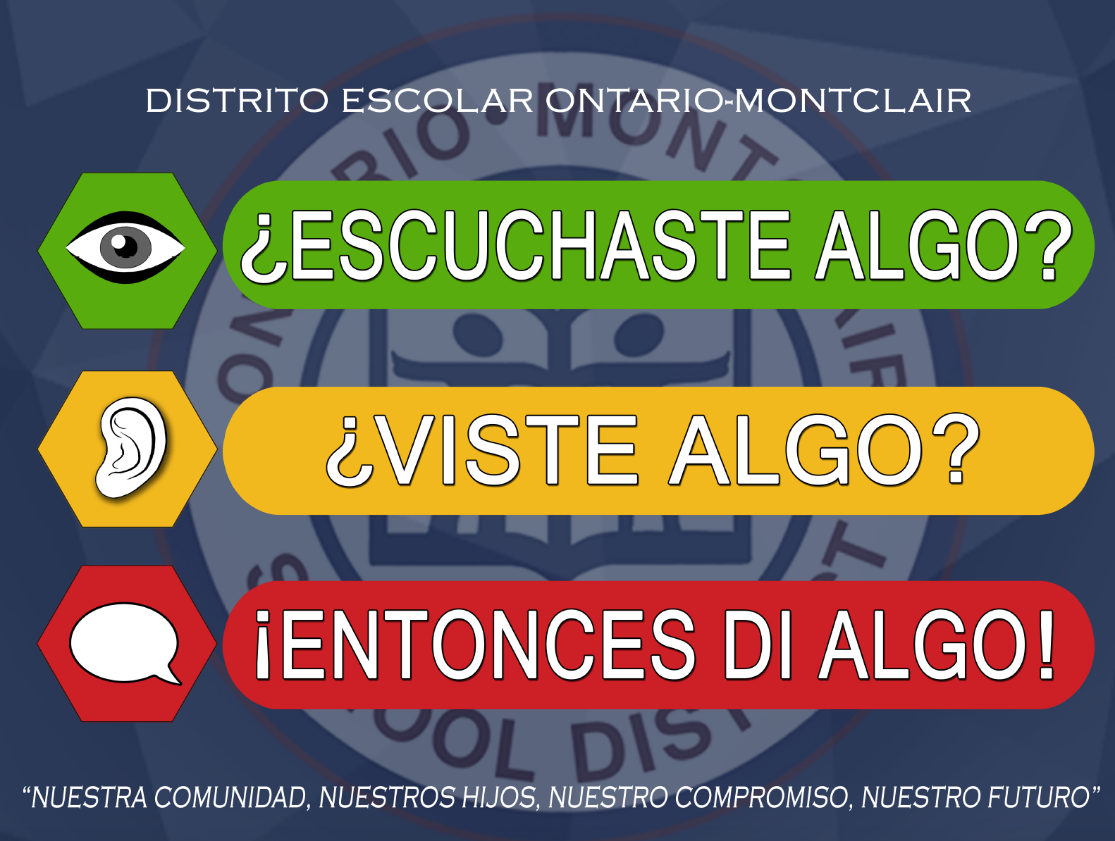

**Ray Wiltsey**

**PBIS Student**

**Handbook**

**2025-2026**



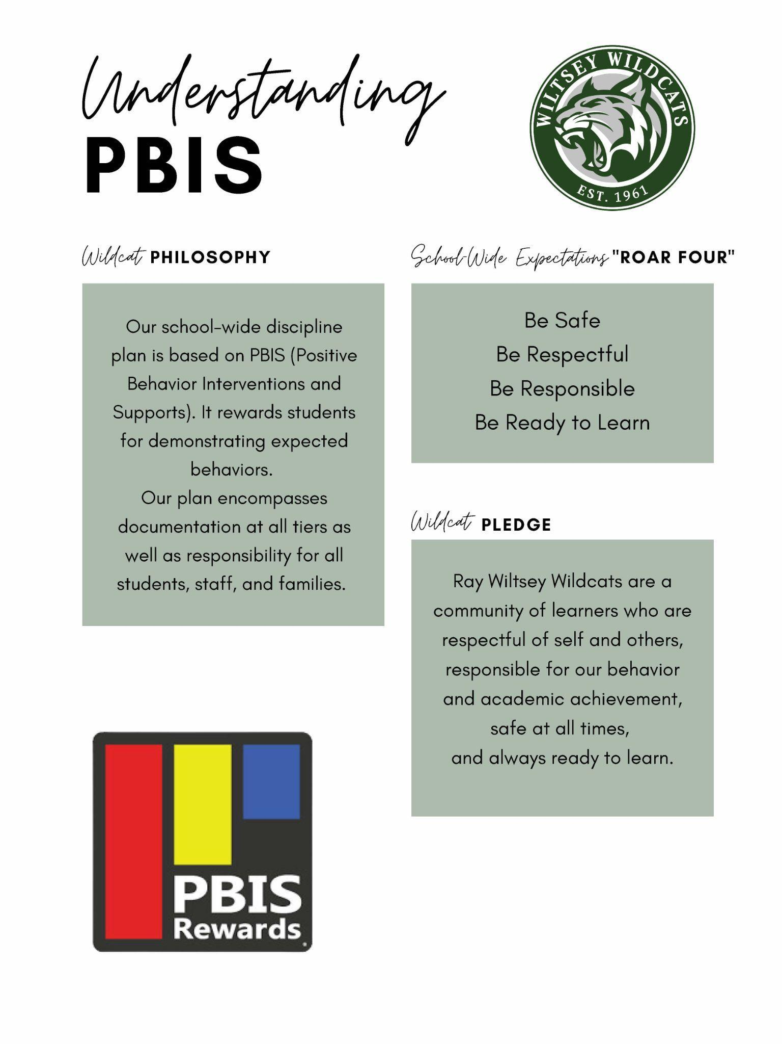

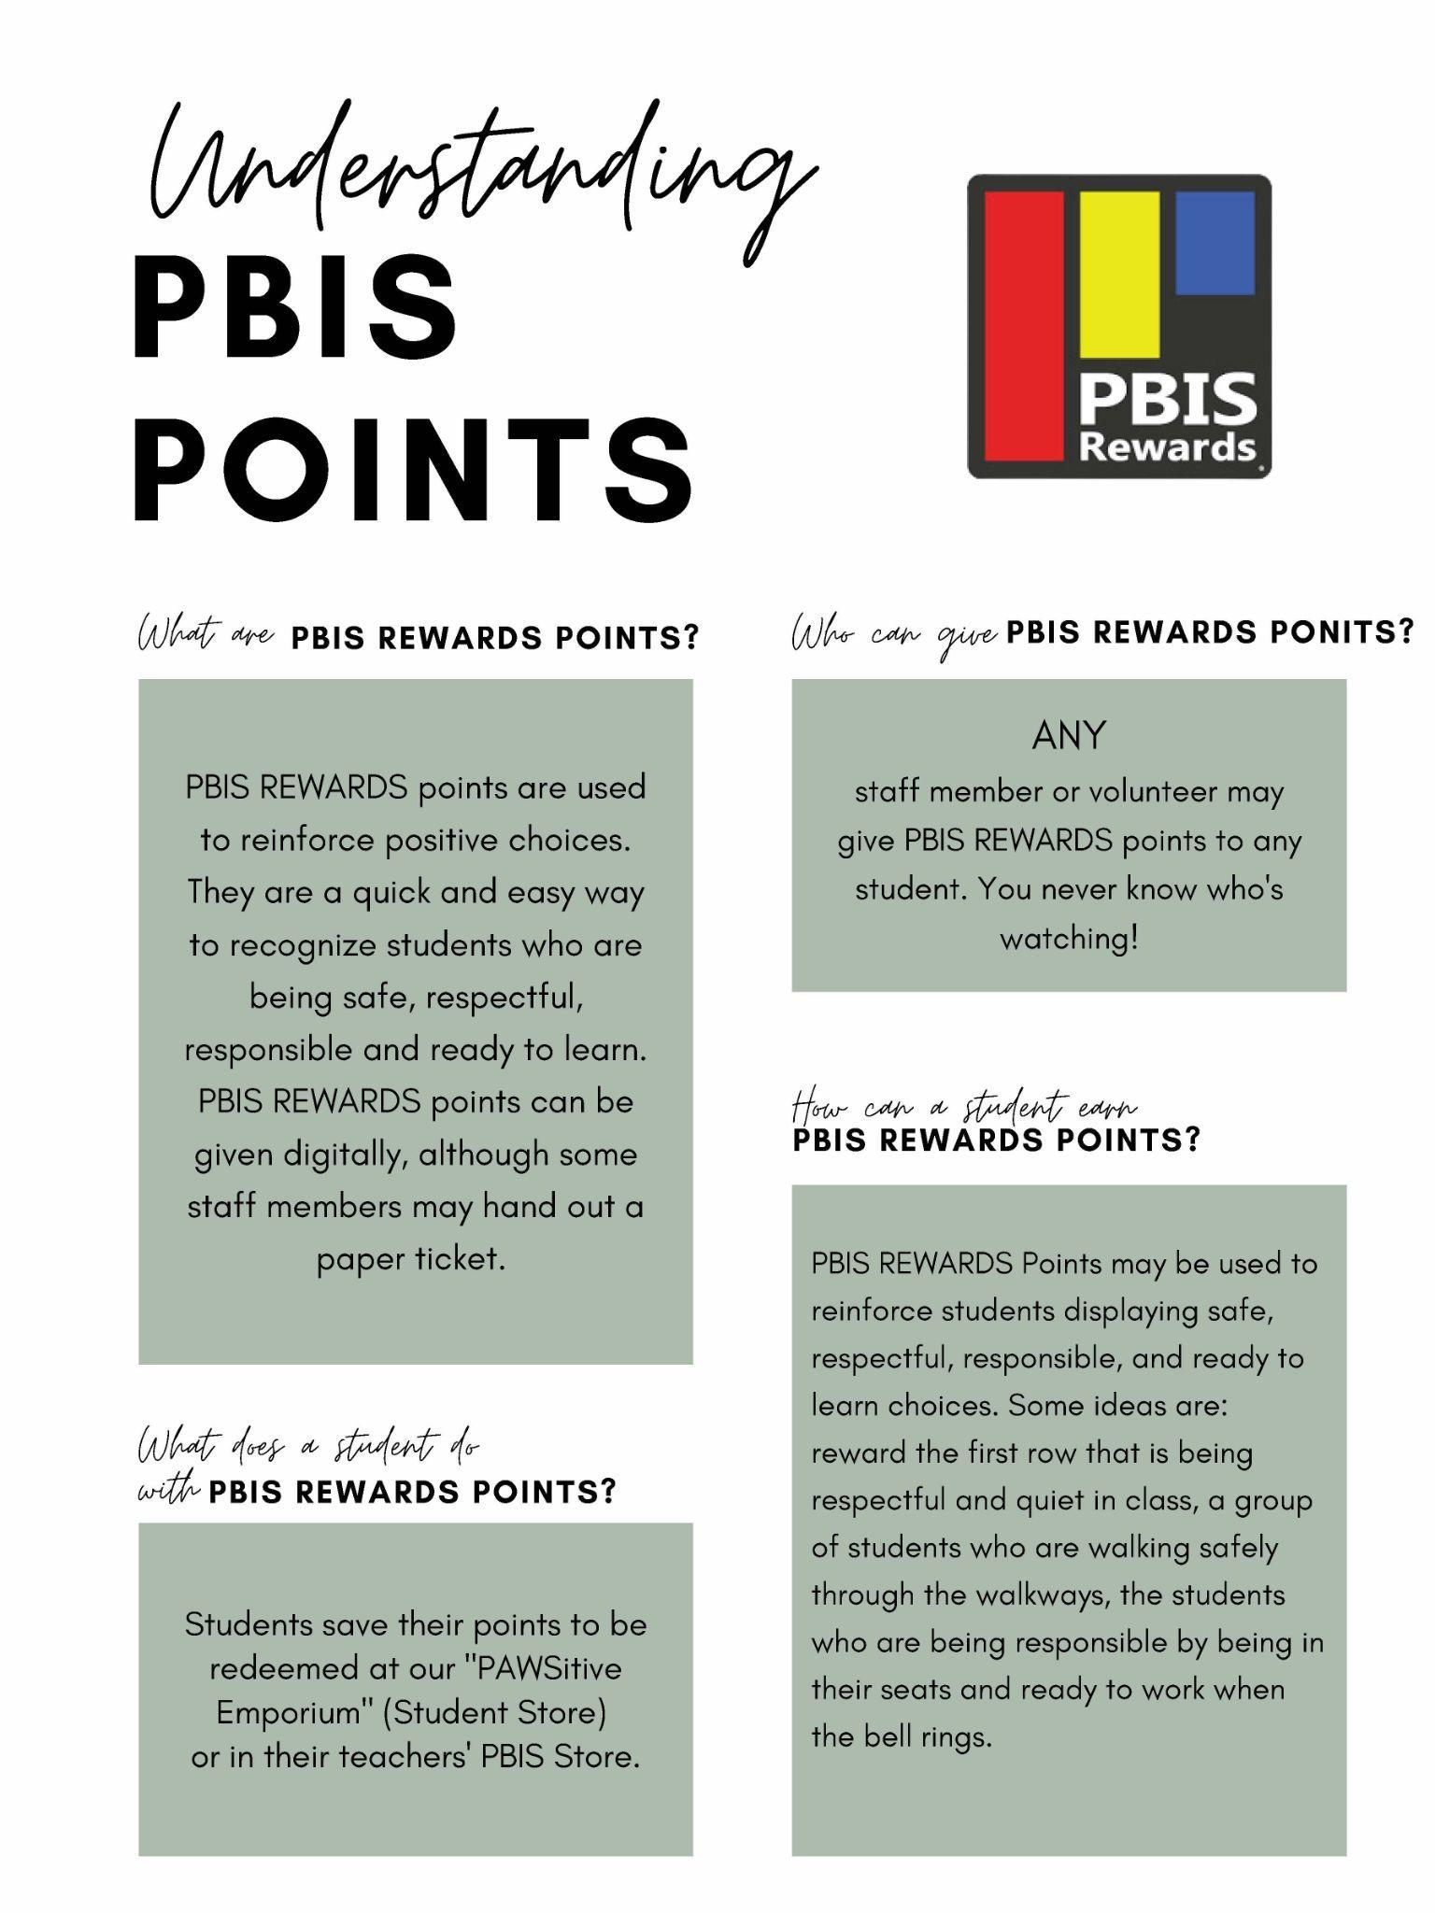

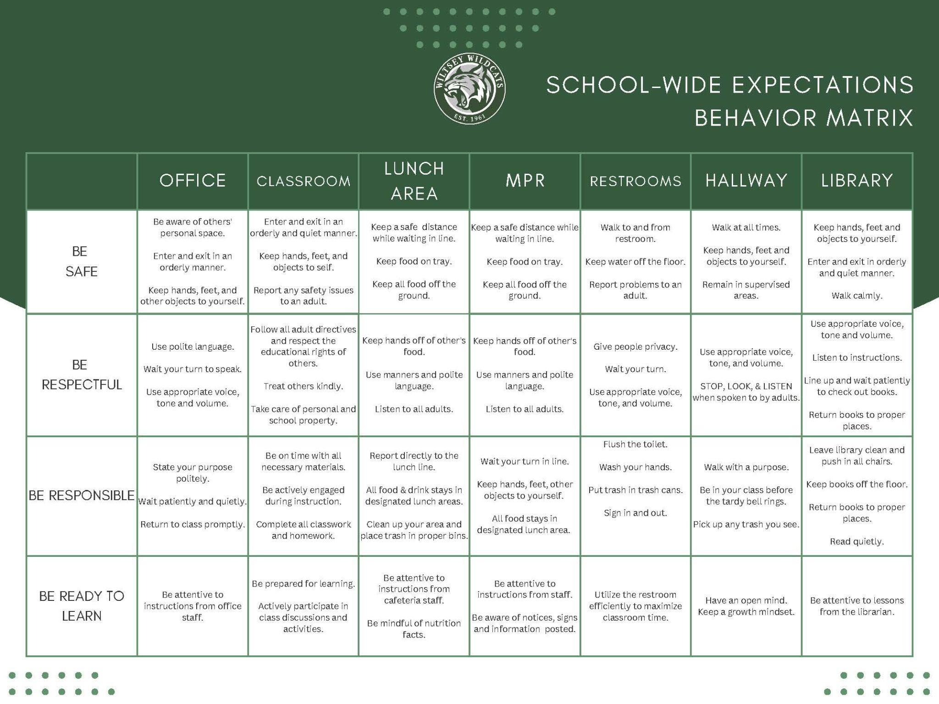

**Ray Wiltsey Middle School**

**Parent Involvement Policy**

**2025-2026**

Ray Wiltsey Middle School has developed a written Title I Parental Involvement Policy with input from Title I parents. This Parental Involvement Policy was developed with input from parents during the course of several parent meetings including the School Site Council, English Learner Advisory Committee, Coffee with the Principal and Back to School Night*.* Ray Wiltsey Middle School has distributed the policy to parents of Title I students. The Parental Involvement Policy is distributed to parents during the student registration process at the beginning of the school year. Additional copies are made available in the office and distributed to new enrollee parents as part of the enrollment process. The policy describes the means for carrying out the following Title I parental involvement requirements [*20 USC* 6318 Section 1118(a)-(f) inclusive].

**Involvement of Parents in the Title I Program**

To involve parents in the Title I program at Ray Wiltsey Middle School, the following practices have been established:

* The school convenes an annual meeting to inform parents of Title I students about Title I requirements and about the right of parents to be involved in the Title I program.   
  The annual meeting takes place at the Ray Wiltsey Back To School Night prior to classroom visits.
* The school offers a flexible number of meetings for Title I parents.
* The Title I program is also reviewed with parents during School Site Council, SELPAC, and Coffee with the Administration meetings.
* The school involves parents of Title I students in an organized, ongoing, and timely manner, in the planning, review, and improvement of the school’s Title I programs and the Title I Parental Involvement Policy.
* The school provides parents of Title I students with timely information about Title I programs.  
  All Ray Wiltsey Middle School students are given a planner as a communication tool for teachers to inform parents about their programs. Ray Wiltsey Middle School also uses School Loop to communicate with parents about programs and important meetings.
* The school provides parents of Title I students with an explanation of the school curriculum, the assessments used to measure student progress, and the proficiency levels students are expected to meet.  
  These opportunities take place at:
  + Student-Led/Parent Conferences
  + Coffee with The Principal
  + Parent Education Workshops
  + School Site Council
  + SELPAC
* If requested by parents of Title I students, the school provides opportunities for regular meetings that allow the parents to participate in decisions relating to the education of their children.  
  These opportunities take place at:
  + Coordination of Services Team
  + Student Study Team
  + School Site Council
  + Site English Learner Advisory Council
  + Coffee with the Principal

**School-Parent Compact**

*Ray Wiltsey Middle School* distributes to parents of Title I students a school-parent compact. The compact, which has been jointly developed with parents, outlines how parents, the entire school staff, and students will share the responsibility for improved student academic achievement. It describes specific ways the school and families will partner to help children achieve the State’s high academic standards. It addresses the following legally required items, as well as other items suggested by parents of Title I students.

* The school’s responsibility to provide high-quality curriculum and instruction
* The ways parents will be responsible for supporting their children’s learning
* The importance of ongoing communication between parents and teachers through, at a minimum, annual parent-teacher conferences; frequent reports on student progress; access to staff; opportunities for parents to volunteer and participate in their child’s class; and opportunities to observe classroom activities

*The Parental Involvement Policy was developed with input from parents given during School Site Council meetings, Site English Learner Advisory Council meetings, and Coffee with the Principal meetings. The Parental Involvement Policy and compact are distributed to parents during the registration process at the beginning of each school year. In addition, they are available in the front office and are given to parents of new enrollees with the registration packet.*

**Building Capacity for Involvement**

*Ray Wiltsey Middle School* engages Title I parents in meaningful interactions with the school. It supports a partnership among staff, parents, and the community to improve student academic achievement. To help reach these goals, the school has established the following practices.

* The school provides Title I parents with assistance in understanding the State’s academic content standards, assessments, and how to monitor and improve the achievement of their children.   
  *Ray Wiltsey Middle School will provide parents of participating children a description and explanation of the curriculum in use at the school, the forms of academic assessment used to measure student progress, and the proficiency levels students are expected to meet at:*
  + *Parent-Teacher Conferences*
  + *Coffee with Administration*
  + *Parent Education Workshops*
* The school provides Title I parents with materials and training to help them work with their children to improve their children's achievement.   
  *Ray Wiltsey Middle School will:*
* *Provide parent-teacher conferences for all parents of students performing below expectations; and providing instructional resources that would assist parents in working with their children and understanding educational topics.*
* *Provide all parents of students performing below expectations; the opportunity to attend literacy and numeracy workshops that would assist parents in working with their children and understanding education topics.*
* With the assistance of Title I parents, the school educates staff members about the value of parent contributions, and in how to work with parents as equal partners.

*Ray Wiltsey Middle School will, with the assistance of its district and parents, educate its teachers, pupil services personnel, and other staff, in how to reach out to communicate with, and work with parents as equal partners, in the value and utility of contributions of parents, and in how to implement and coordinate parent programs and build ties between parents and schools, by:*

* + *Professional Development*
  + *Articles/Newsletters*
  + *Resource materials and brochures*
* The school coordinates and integrates the Title I parental involvement program with other programs, and conducts other activities, such as parent resource centers, to encourage and support parents in more fully participating in the education of their children.

*The school will, with assistance of its District, provide materials and training to help parents work with their children to improve their children’s academic achievement, such as literacy training, and technology, as appropriate to foster parental involvement by:*

* + *Providing parent-teacher conferences for all parents of students performing below expectations; and providing instructional resources that would assist parents in working with their children and understanding educational topics.*
  + *Providing all parents of students performing below expectations; the opportunity to attend literacy and numeracy workshops that would assist parents in working with their children and understanding education topics.*
* The school distributes Information related to school and parent programs, meetings, and other activities to Title I parents in a format and language that the parents understand.

*Ray Wiltsey staff distributes Information related to school and parent programs, meetings, and other activities in both English and Spanish. All home communication bulletins and all flyers and newsletters are translated and sent home in a language the parents can understand.  Ray Wiltsey staff has bilingual personnel to facilitate translation and uses District personnel when necessary.*

* The school provides support for parental involvement activities requested by Title I parents.

*Ray Wiltsey Middle School will build the schools’ and parents’ capacity for strong parental involvement, in order to ensure effective involvement of parents and to support a partnership among the school involved, parents, and the community to improve student academic achievement through the following activities listed below:*

* + *Information and ideas about the academic work their children do in class.*
  + *Coordinated links between what is happening in the classroom and activities at home.*
  + *Academic goal setting.*
  + *Ideas on how to help their child with homework.*
  + *Increased communications with the teacher.*
  + *Better communication between the parent and child through reviewing student work, practicing skills, monitoring and discussing homework.*

**Accessibility**

*Ray Wiltsey Middle School* provides opportunities for the participation of all Title I parents, including parents with limited English proficiency, parents with disabilities, and parents of migratory students. Information and school reports are provided in a format and language that parents understand.

*Ray Wiltsey Middle School will invite all parents of children participating in Title I, Part A programs to all parent meetings and events and will encourage them to attend by:*

* + *Communicating through telephone calls, parent-teacher conferences, direct mailing, website posting and/or offering of alternative evening meetings.*
  + *To the extent possible, all information will be translated in the languages represented within the school. In addition, attempts will be made to organize and gather resources to hold a minimum of one parent meeting in a language other than English.*
  + *Convene the meeting at a time convenient for parents and will offer a flexible number of additional parental involvement meeting*

**Ontario-Montclair SD**

**Board Policy**

**Sexual Harassment**

BP 5145.7

**Students**

The Board of Trustees is committed to maintaining a safe school environment that is free from harassment and discrimination. The Board prohibits, at school or at school-sponsored or school-related activities, sexual harassment targeted at any student by anyone. The Board also prohibits retaliatory behavior or action against any person who reports, files a complaint or testifies about, or otherwise supports a complainant in alleging sexual harassment.

The district strongly encourages any student who feels that he/she is being or has been sexually harassed on school grounds or at a school-sponsored or school-related activity by another student or an adult who has experienced off-campus sexual harassment that has a continuing effect on campus to immediately contact his/her teacher, the principal, or any other available school employee. Any employee who receives a report or observes an incident of sexual harassment shall notify the principal or a district compliance officer. Once notified, the principal or compliance officer shall take the steps to investigate and address the allegation, as specified in the accompanying administrative regulation.

(cf. 0410 - Nondiscrimination in District Programs and Activities)

(cf. 1312.1 - Complaints Concerning District Employees)

(cf. 5131 - Conduct)

(cf. 5131.2 - Bullying)

(cf. 5137 - Positive School Climate)

(cf. 5141.4 - Child Abuse Prevention and Reporting)

(cf. 5145.3 - Nondiscrimination/Harassment)

(cf. 6142.1 - Sexual Health and HIV/AIDS Prevention Instruction)

The Superintendent or designee shall take appropriate actions to reinforce the district's sexual harassment policy.

Instruction/Information

The Superintendent or designee shall ensure that all district students receive age-appropriate information on sexual harassment. Such instruction and information shall include:

1. What acts and behavior constitute sexual harassment; including the fact that sexual harassment could occur between people of the same sex and could involve sexual violence

2. A clear message that students do not have to endure sexual harassment under any circumstance

3. Encouragement to report observed incidents of sexual harassment even where the alleged victim of the harassment has not complained

4. A clear message that student safety is the district's primary concern, and that any separate rule violation involving an alleged victim or any other person reporting a sexual harassment incident will be addressed separately and will not affect the manner in which the sexual harassment complaint will be received, investigated, or resolved

5. A clear message that, regardless of a complainant's noncompliance with the writing, timeline, or other formal filing requirements, every sexual harassment allegation that involves a student, whether as the complainant, respondent, or victim of the harassment, shall be investigated and prompt action shall be taken to stop any harassment, prevent recurrence, and address any continuing effect on students

6. Information about the district's procedure for investigating complaints and the person(s) to whom a report of sexual harassment should be made

7. Information about the rights of students and parents/guardians to file a civil or criminal complaint, as applicable, including the right to file a civil or criminal complaint while the district investigation of a sexual harassment complaint continues

8. A clear message that, when needed, the district will take interim measures to ensure a safe school environment for a student who is the complainant or victim of sexual harassment and/or other students during an investigation and that, to the extent possible, when such interim measures are taken, they shall not disadvantage the complainant or victim of the alleged harassment

Complaint Process and Disciplinary Actions

Sexual harassment complaints by and against students shall be investigated and resolved in accordance with law and district procedures specified in AR 1312.3- Uniform Complaint Procedures. Principals are responsible for notifying students and parents/guardians that complaints of sexual harassment can be filed under AR 1312.3 and where to obtain a copy of the procedures.

(cf. 1312.3- Uniform Complaint Procedures)

Upon investigation of a sexual harassment complaint, any student found to have engaged in sexual harassment or sexual violence in violation of this policy shall be subject to disciplinary action. For students in grades 4-12, disciplinary action may include suspension and/or expulsion, provided that, in imposing such discipline, the entire circumstances of the incident(s) shall be taken into account.

(cf. 5144 - Discipline)

(cf. 5144.1 - Suspension and Expulsion/Due Process)

(cf. 5144.2 - Suspension and Expulsion/Due Process (Students with Disabilities))

Upon investigation of a sexual harassment complaint, any employee found to have engaged in sexual harassment or sexual violence toward any student shall have his/her employment terminated in accordance with law and the applicable collective bargaining agreement.

(cf. 4117.7 - Employment Status Report)

(cf. 4118 - Dismissal/Suspension/Disciplinary Action)

(cf. 4218 - Dismissal/Suspension/Disciplinary Action)

(cf. 4119.11/4219.11/4319.11 - Sexual Harassment)

Record-Keeping

The Superintendent or designee shall maintain a record of all reported cases of sexual harassment to enable the district to monitor, address, and prevent repetitive harassing behavior in district schools.

(cf. 3580 - District Records)

Legal Reference: EDUCATION CODE 200-262.4 Prohibition of discrimination on the basis of sex 48900 Grounds for suspension or expulsion 48900.2 Additional grounds for suspension or expulsion; sexual harassment 48904 Liability of parent/guardian for willful student misconduct 48980 Notice at beginning of term CIVIL CODE 51.9 Liability for sexual harassment; business, service and professional relationships 1714.1 Liability of parents/guardians for willful misconduct of minor GOVERNMENT CODE 12950.1 Sexual harassment training CODE OF REGULATIONS, TITLE 5 4600-4687 Uniform complaint procedures 4900-4965 Nondiscrimination in elementary and secondary education programs UNITED STATES CODE, TITLE 20 1221 Application of laws 1232g Family Educational Rights and Privacy Act 1681-1688 Title IX, discrimination UNITED STATES CODE, TITLE 42 1983 Civil action for deprivation of rights 2000d-2000d-7 Title VI, Civil Rights Act of 1964 2000e-2000e-17 Title VII, Civil Rights Act of 1964 as amended CODE OF FEDERAL REGULATIONS, TITLE 34 99.1-99.67 Family Educational Rights and Privacy

106.1-106.71 Nondiscrimination on the basis of sex in education programs COURT DECISIONS Donovan v. Poway Unified School District, (2008) 167 Cal. App. 4th 567 Flores v. Morgan Hill Unified School District, (2003, 9th Cir.) 324 F.3d 1130 Reese v. Jefferson School District, (2001, 9th Cir.) 208 F.3d 736 Davis v. Monroe County Board of Education, (1999) 526 U.S. 629 Gebser v. Lago Vista Independent School District, (1998) 524 U.S. 274 Oona by Kate S. v. McCaffrey, (1998, 9th Cir.) 143 F.3d 473 Doe v. Petaluma City School District, (1995, 9th Cir.) 54 F.3d 1447

Management Resources:

CSBA PUBLICATIONS

Providing a Safe, Nondiscriminatory School Environment for Transgender and Gender-Nonconforming Students, Policy Brief, February 2014 Safe Schools: Strategies for Board of Trustees to Ensure Student Success, 2011 U.S. DEPARTMENT OF EDUCATION, OFFICE FOR CIVIL RIGHTS PUBLICATIONS Dear Colleague Letter: Transgender Students, May 2016 Examples of Policies and Emerging Practices for Supporting Transgender Students, May 2016 Dear Colleague Letter: Title IX Coordinators, April 2015 Questions and Answers on Title IX and Sexual Violence, April 2014 Dear Colleague Letter: Sexual Violence, April 4, 2011 Sexual Harassment: It's Not Academic, September 2008 Revised Sexual Harassment Guidance: Harassment of Students by School Employees, Other Students, or Third Parties, January 2001 WEB SITES CSBA: http://www.csba.org California Department of Education: http://www.cde.ca.gov U.S. Department of Education, Office for Civil Rights: [http://www.ed.gov/about/offices/list/o](http://www.ed.gov/about/offices/list/ocr)cr

Policy ONTARIO-MONTCLAIR SCHOOL DISTRICT

adopted: January 19, 2017 Ontario, California

**Distrito Escolar Ontario-Montclair**

**Política de la Junta**

Acoso sexual

BP 5145.7

**Estudiante**

La Mesa Directiva está comprometida a mantener un entorno escolar que esté libre de acoso y a Directiva prohíbe, en la escuela o en actividades patrocinadas por la escuela el acoso sexual dirigido a cualquier alumno por cualquier persona. La junta directiva también prohíbe las represalias o acciones en contra de cualquier persona que delate, presente una queja o testifique o respalde a un denunciante que alega acoso sexual.

El distrito recomienda encarecidamente a cualquier estudiante quien sienta que ha sido acosado o está siendo acosado en la escuela o en una actividad patrocinada o relacionada con la escuela por otro estudiante o un adulto quien ha sufrido acoso sexual fuera de la escuela que tiene un efecto indeleble en la escuela que se comunique inmediatamente con su maestro, el director/a o cualquier otro empleado disponible de la escuela. Cualquier empleado quien recibe un informe u observa un incidente de acoso sexual deberá notificar al director o al oficial de cumplimiento. Una vez que lo notifique, el director o el oficial de cumplimiento deberán tomar los pasos necesarios para investigar y abordar la denuncia, como es especificado en el reglamento administrativo adjunto.

(cf. 04 10- No discriminación en los programas y actividades del distrito)

(cf. 1312.1- Quejas concernientes con respecto a empleados del distrito)

(cf. 5131 - Conducta) (cf. 5131.2 - Acoso)

(cf. 5137 - Entorno escolar positivo)

(cf. 5141.4 - Prevención y denuncia de abuso infantil)

(cf. 5145.3- No discriminación/Acoso)

(cf. 6142.1 – Instrucción de prevención de salud y VIH/SIDA)

El superintendente o persona designada deberá tomar las medidas apropiadas para reforzar la política de acoso sexual en el distrito.

Instrucción/Información

El superintendente o persona designada deberán asegurarse que todos los estudiantes del distrito reciben información de acoso sexual apropiada a la edad. Dicha instrucción e información deberá incluir:

1. Qué actos y comportamiento constituyen acoso sexual, incluyendo el hecho de que el acoso sexual puede ocurrir entre personas del mismo sexo y convertirse en violencia sexual.

2. Un mensaje claro de que los estudiantes no tienen que soportar el acoso sexual bajo ninguna circunstancia.

3. Exhortarlos para que delaten incidentes de acoso sexual aun cuando la presunta víctima del acoso no se haya quejado.

4. Un mensaje claro de que la seguridad del estudiante es la principal preocupación del distrito y que cualquier violación a una regla separada que involucre a una presunta víctima o a cualquier otra persona que delate un incidente de acoso sexual se tratará por separado y no afectará el momento en que la queja de acoso sexual sea recibida, investigada o resuelta.

5. Un mensaje claro de que, en relación con el incumplimiento por parte del demandante de presentar por escrito, en un plazo de tiempo o de otro requisito formal, cada alegato de acoso sexual que tenga que ver con un estudiante, ya sea que sea como demandante, demandado o víctima del acoso, será investigado y se tomarán medidas inmediatas para detener cualquier hostigamiento, prevenir la recurrencia y abordar cualquier efecto continuo que tenga en los estudiantes.

6. Información sobre el procedimiento que utiliza el distrito para investigar quejas y a que persona se le debe presentar la denuncia.

7. Información sobre los derechos de los estudiantes y padres o tutores para presentar una queja civil o criminal, según corresponda, incluyendo el derecho a presentar una queja civil o criminal mientras continúa la investigación del distrito sobre el acoso sexual.

8. Un mensaje claro de que, cuando sea necesario, el distrito tomará medidas provisionales para garantizar un entorno escolar seguro para un estudiante quien es el denunciante o víctima de acoso sexual y /u otros estudiantes durante una investigación y que en la medida de lo posible, cuando se tomen tales medidas provisionales, no pondrán en desventaja al denunciante o a la víctima del presunto acoso sexual.

Procedimientos de quejas y medidas disciplinarias

Las quejas sobre acoso sexual por y en contra de los estudiantes deberán ser investigadas y resueltas de acuerdo a la ley y a los procedimientos del distrito especificados en AR 1312.3 - Procedimientos uniformes para presentar quejas. Los directores son responsables de notificar a los estudiantes y a los padres o tutores que las quejas sobre acoso sexual pueden ser archivadas bajo AR 13 12.3 y en donde obtener una copia de los procedimientos.

(cf. 13 12.3 - Procedimientos para presentar quejas)

Tras la investigación de una denuncia de acoso sexual, cualquier estudiante que se encuentre involucrado en acoso sexual o violencia sexual en violación de esta política estará sujeto a medidas disciplinarias. Para los estudiantes de 4o a 12 avo grado, las medidas disciplinarias pueden incluir la suspensión y/o expulsión, siempre que, al imponer tal disciplina, se tengan en cuenta todas las circunstancias del incidente.

(cf. 5 144 - Disciplina) (cf. 5144.1- Suspensión y Expulsión/Proceso debido) (cf. 5144.2 - Suspensión y Expulsión /Debido proceso (Estudiante con discapacidades))

Tras la investigación de una denuncia de acoso sexual, cualquier empleado que se encuentre involucrado en el acoso o violencia sexual en contra de cualquier estudiante deberá ser despedido de su empleo de conformidad con la ley y el acuerdo de negociación colectiva correspondiente.

(cf. 4 117.7- Informe del estado del empleo)

(cf. 4218 - Despido/Suspensión/Medida disciplinaria)

(cf. 4119.11/4219.11/4319.11- Acoso sexual)

Mantenimiento de registros

El superintendente o persona designada mantendrá un registro de todos los casos de acoso sexual que han sido denunciados con el fin de permitir que el distrito controle, aborde y evite el comportamiento de acoso repetitivo en las escuelas del distrito..

(cf. 3580- Registros del distrito)

Referencia legal: CÓDIGO DE EDUCACIÓN

200-262.4 Prohibición de discriminación por sexo 48900 Motivos de suspensión o expulsión 4900 2 Motivos adicionales para suspensión o expulsión; acoso sexual

48904 Responsabilidad de los padres o tutores por la conducta intencional del menor

48980 Aviso al principio del término

CÓDIGO CIVIL

51.9 Responsabilidad por acoso sexual; relaciones empresariales, servicios y profesionales 1714.1 Responsabilidad de los padres o tutores por mala conducta intencional del menor CÓDIGO DEL GOBIERNO 12950. 1 Capacitación sobre acoso sexual CÓDIGO DE REGLAMENTOS, TÍTULO 5 4600-4687 Procedimientos para presentar quejas 4900-4965 No discriminación en programas de educación primaria y secundaria

CÓDIGO DE ESTADOS UNIDOS, TÍTULO 20

1221 Aplicación de las leyes 1232g Ley de privacidad y derechos educativos de la familia 1681-1688 Título IX, discriminación

CÓDIGO DE ESTADOS UNIDOS, TÍTULO 42

1983 Acción civil por privación de derechos 2000d -2000d-7 Título VI, Acta de derechos civiles de1964 2000e-2000e- 17 Título VII, Acta de derechos civiles de 1964 como fue enmendada CODIGO DE REGLAMENTOS FEDERALES, TÍTULO 34 99.1-99.67 Derechos educativos y de privacidad de la familia 106.1-106.71 No discriminación en base al sexo en los programas de educación DECISIONES DE LOS TRIBUNALES Donovan v. Distrito Escolar Unificado Poway, (2008) 167 Cai.App.4th 567

Flores v. Distrito Escolar Unificado Morgan Hill, (2003, 9th Cir.) 324 F.3d 1130

Reese v. Distrito Unificado Jefferson, (2001, 9th Cir.) 208 F.3d 736

Davis v. Secretaría de Educación del Condado de Monroe, (1999) 526 U.S.629

Gebser v. Distrito Escolar Independiente Lago Vista, (1998) 524 U.S. 274

Oona by KateS. v. McCaffrey, (1998, 9th Cir.) 143 F.3d 473

Doe v. Distrito Escolar Ciudad de Petaluma, (1995, 9th Cir.) 54 F.3d 1447

Recursos administrativos

PUBLICACIONES CSBA

Proporcionar un lugar seguro y no discriminatorio para estudiantes transgénero y no conformes con el género, Informe de política, febrero de 2014

Escuelas seguras: Estrategias para la Mesa Directiva con el fin de asegurar el éxito de los estudiantes, 2011

DEPARTAMENTO DE EDUCACIÓN DE LOS ESTADOS UNIDOS, PUBLICACIONES DE LA OFICINA DE DERECHOS CIVILES

Carta Estimado colega: Estudiantes transgénero, Mayo 2016

Ejemplos de políticas y prácticas emergentes para apoyar a los estudiantes transgénero, mayo de 2016

Carta Estimado colega: Coordinadores de Título IX, abril de 2015

Preguntas y respuestas sobre el Título IX y la Violencia sexual, abril de 2014

Carta estimado colega: Violencia sexual, 4 de abril de 2011

El acoso sexual: No es académico, Septiembre 2008

Guía revisada de acoso sexual: hostigamiento de estudiantes por parte de empleados escolares, otros estudiantes o terceros, Enero de 2001 SITIOS WEB

CSBA: http://www.csba.org

Departamento de Educación de California: http://www.cde.ca.gov

Departamento de Educación, Oficina de Derechos Civiles: http://www.ed.gov/about/offices/list/oer

Política del DISTRITO ESCOLAR ONTARIO-MONTCLAIR

Adoptada: 19 de enero de 2017 Ontario, California

**Ontario-Montclair SD**

**Board Policy**

**Nondiscrimination/Harassment**

BP 5145.3

**Students**

The Board of Trustees desires to provide a safe school environment that allows all students equal access and opportunities in the district's academic, extracurricular, and other educational support programs, services, and activities. The Board prohibits, at any district school or school activity, unlawful discrimination, including discriminatory harassment, intimidation, and bullying, targeted at any student by anyone, based on the student's actual or perceived race, color, ancestry, national origin, nationality, ethnicity, ethnic group identification, age, religion, marital or parental status, physical or mental disability, sex, sexual orientation, gender, gender identity, or gender expression or association with a person or group with one or more of these actual or perceived characteristics.

This policy shall apply to all acts related to school activity or to school attendance occurring within a district school, and to acts which occur off campus or outside of school-related or school-sponsored activities but which may have an impact or create a hostile environment at school.

(cf. 0410 - Nondiscrimination in District Programs and Activities)

(cf. 5131 - Conduct)

(cf. 5131.2 - Bullying)

(cf. 5137 - Positive School Climate)

(cf. 5145.9 - Hate-Motivated Behavior)

(cf. 5146 - Married/Pregnant/Parenting Students)

(cf. 6164.6 - Identification and Education Under Section 504)

Unlawful discrimination, including discriminatory harassment, intimidation, or bullying, may result from physical, verbal, nonverbal, or written conduct based on any of the categories listed above. Unlawful discrimination also includes the creation of a hostile environment through prohibited conduct that is so severe, persistent, or pervasive that it affects a student's ability to participate in or benefit from an educational program or activity; creates an intimidating, threatening, hostile, or offensive educational environment; has the effect of substantially or unreasonably interfering with a student's academic performance; or otherwise adversely affects a student's educational opportunities.

Unlawful discrimination also includes disparate treatment of students based on one of the categories above with respect to the provision of opportunities to participate in school programs or activities or the provision or receipt of educational benefits or services.

The Board also prohibits any form of retaliation against any individual who reports or participates in the reporting of unlawful discrimination, files or participates in the filing of a complaint, or investigates or participates in the investigation of a complaint or report alleging unlawful discrimination. Retaliation complaints shall be investigated and resolved in the same manner as a discrimination complaint.

The Superintendent or designee shall facilitate students' access to the educational program by publicizing the district's nondiscrimination policy and related complaint procedures to students, parents/guardians, and employees. He/she shall provide training and information on the scope and use of the policy and complaint procedures and take other measures designed to increase the school community's understanding of the requirements of law related to discrimination. The Superintendent or designee shall regularly review the implementation of the district's nondiscrimination policies and practices and, as necessary, shall take action to remove any identified barrier to student access to or participation in the district's educational program. He/she shall report his/her findings and recommendations to the Board after each review.

(cf. 1312.3 - Uniform Complaint Procedures)

(cf. 1330 - Use of Facilities)

(cf. 4131 - Staff Development)

(cf. 4231 - Staff Development)

(cf. 4331 - Staff Development)

(cf. 6145 - Extracurricular and Co-curricular Activities)

(cf. 6145.2 - Athletic Competition)

(cf. 6164.2 - Guidance/Counseling Services)

Regardless of whether a complainant complies with the writing, timeline, and/or other formal filing requirements, all complaints alleging unlawful discrimination, including discriminatory harassment, intimidation, or bullying, shall be investigated and prompt action taken to stop the discrimination, prevent recurrence, and address any continuing effect on students.

Students who engage in unlawful discrimination, including discriminatory harassment, intimidation, retaliation, or bullying, in violation of law, Board policy, or administrative regulation shall be subject to appropriate consequence or discipline, which may include suspension or expulsion when the behavior is severe or pervasive as defined in Education Code 48900.4. Any employee who permits or engages in prohibited discrimination, including discriminatory harassment, intimidation, retaliation, or bullying, shall be subject to disciplinary action, up to and including dismissal.

(cf. 4118 - Suspension/Disciplinary Action)

(cf. 4119.21/4219.21/4319.21 - Professional Standards)

(cf. 4218 - Dismissal/Suspension/Disciplinary Action)

(cf. 5144 - Discipline)

(cf. 5144.1 - Suspension and Expulsion/Due Process)

(cf. 5144.2 - Suspension and Expulsion/Due Process (Students with Disabilities)

(cf. 5145.2 - Freedom of Speech/Expression)

Record-Keeping

The Superintendent or designee shall maintain a record of all reported cases of unlawful discrimination, including discriminatory harassment, intimidation, or bullying, to enable the district to monitor, address, and prevent repetitive prohibited behavior in district schools.

(cf. 3580 - District Records)

Legal Reference:

EDUCATION CODE 200-262.4 Prohibition of discrimination 48900.3 Suspension or expulsion for act of hate violence 48900.4 Suspension or expulsion for threats or harassment 48904 Liability of parent/guardian for willful student misconduct 48907 Student exercise of free expression 48950 Freedom of speech 48985 Translation of notices 49020-49023 Athletic programs 51500 Prohibited instruction or activity 51501 Prohibited means of instruction 60044 Prohibited instructional materials CIVIL CODE 1714.1 Liability of parents/guardians for willful misconduct of minor PENAL CODE 422.55 Definition of hate crime 422.6 Crimes, harassment CODE OF REGULATIONS, TITLE 5 432 Student record 4600-4687 Uniform complaint procedures 4900-4965 Nondiscrimination in elementary and secondary education programs UNITED STATES CODE, TITLE 20 1681-1688 Title IX of the Education Amendments of 1972 12101-12213 Title II equal opportunity for individuals with disabilities UNITED STATES CODE, TITLE 29 794 Section 504 of Rehabilitation Act of 1973

UNITED STATES CODE, TITLE 42 2000d-2000e-17 Title VI and Title VII Civil Rights Act of 1964, as amended 2000h-2-2000h-6 Title IX of the Civil Rights Act of 1964 6101-6107 Age Discrimination Act of 1975 CODE OF FEDERAL REGULATIONS, TITLE 28 35.107 Nondiscrimination on basis of disability; complaints CODE OF FEDERAL REGULATIONS, TITLE 34 99.31 Disclosure of personally identifiable information 100.3 Prohibition of discrimination on basis of race, color or national origin 104.7 Designation of responsible employee for Section 504

106.8 Designation of responsible employee for Title IX 106.9 Notification of nondiscrimination on basis of sex COURT DECISIONS Donovan v. Poway Unified School District, (2008) 167 Cal.App.4th 567 Flores v. Morgan Hill Unified School District, (2003) 324 F.3d 1130

Management Resources: CSBA PUBLICATIONS Providing a Safe, Nondiscriminatory School Environment for Transgender and Gender-Nonconforming Students, Policy Brief, February 2014 Final Guidance Regarding Transgender Students, Privacy, and Facilities, March 2014 Safe Schools: Strategies for Board of Trustees to Ensure Student Success, 2011 FIRST AMENDMENT CENTER PUBLICATIONS Public Schools and Sexual Orientation: A First Amendment Framework for Finding Common

Ground, 2006 NATIONAL SCHOOL BOARDS ASSOCIATION PUBLICATIONS Dealing with Legal Matters Surrounding Students' Sexual Orientation and Gender Identity, 2004 U.S. DEPARTMENT OF EDUCATION, OFFICE FOR CIVIL RIGHTS PUBLICATIONS Dear Colleague Letter: Transgender Students, May 2016 Examples of Policies and Emerging Practices for Supporting Transgender Students, May 2016 Dear Colleague Letter: Title IX Coordinators, April 2015 Dear Colleague Letter: Harassment and Bullying, October 2010 Notice of Non-Discrimination, January 1999 WEB SITES CSBA: http://www.csba.org California Department of Education: http://www.cde.ca.gov California Safe Schools Coalition: http://www.casafeschools.org First Amendment Center: http://www.firstamendmentcenter.org National School Boards Association: http://www.nsba.org U.S. Department of Education, Office for Civil Rights: http://www.ed.gov/about/offices/list/ocr

Policy ONTARIO-MONTCLAIR SCHOOL DISTRICT

Adopted: January 19, 2017 Ontario, California

**Distrito Escolar Ontario-Montclair**

**Política de la Junta**

**No discriminación/Acoso**

BP 5145.3

**Estudiante**

La Mesa Directiva desea brindar un entorno escolar seguro que les permita a todos los estudiantes igualdad de oportunidades y de que tengan acceso a los programas académicos, extracurriculares y a otros programas de apoyo educativo, servicios y actividades. La Mesa Directiva prohíbe, en cualquier escuela o actividad escolar del distrito la discriminación ilegal, incluyendo acoso discriminatorio, intimidación y hostigamiento, dirigida a cualquier estudiante por cualquier persona, basada en la raza, color, ascendencia, origen nacional, nacionalidad, etnia, identificación étnica de grupo, edad, religión, estado civil actual o percibido del estudiante o estado parental, físico o discapacidad mental, sexo, orientación sexual, género, identidad de género o expresión o asociación de género con una persona o grupo con una o más de estas características reales o percibidas.

Esta política se aplicará a todos los actos relacionados con la actividad escolar o a la asistencia dentro de una escuela del distrito, y a actos que ocurran fuera de las actividades escolares o patrocinadas por la escuela pero que puedan afectar crear un entorno hostil en la escuela.

(cf.0410 - No discriminación en programas o actividades del distrito

(cf.5131 - Conducta)

(cf. 5131.2 Acoso o intimidación escolar)

(cf.5137 - Entorno escolar positivo)

(cf.5145.9 - Conducta motivada por el odio

(cf. 5146 - Estudiantes casados/embarazadas/Padres)

(cf.6164.6 - Identificación y Educación bajo la Sección 504)

La discriminación ilegal, incluido el hostigamiento discriminatorio, la intimidación o el acoso, puede resultar de una conducta física, verbal, no verbal o escrita basada en cualquiera de las categorías enumeradas anteriormente. La discriminación ilegal también incluye la creación de un entorno hostil a través de un conducto prohibido que es tan grave, persistente o dominante que afecta la capacidad del alumno para participar o beneficiarse de un programa o actividad educativa; crea un entorno educativo intimidante, hostil u ofensivo; tiene el efecto de interferir inaceptablemente o sistemáticamente con el rendimiento académico del estudiante; o de otra manera afecta adversamente las oportunidades educativas de un estudiante.

La discriminación ilegal también incluye el trato dispar de los estudiantes basándose en una de las categorías anteriores con respecto a proporcionar oportunidades para participar en programas o actividades escolares o brindar o recibir beneficios o servicios educativos.

La Mesa Directiva también prohíbe cualquier forma de represalia en contra de cualquier persona que delate o participe en denunciar la discriminación ilegal, presenta o participa en presentar una queja, o investiga o participa en la investigación de una queja o presenta una denuncia alegando discriminación ilegal. Las quejas de represalias deberán ser investigadas y resueltas de la misma manera que la queja de discriminación.

El superintendente o persona designada facilitará el acceso de los estudiantes al programa educativo publicando la política de no discriminación del distrito y los procedimientos de queja relacionados a los estudiantes, padres o tutores legales y empleados. El o ella deberán proveer capacitación e información sobre el alcance y el uso de la política y procedimientos de queja y tomará otras medidas destinadas a aumentar la comprensión de la comunidad escolar de los requisitos de la ley relacionados con la discriminación. El superintendente o persona designada deberá revisar regularmente la implementación de las políticas y prácticas de no discriminación del distrito y según sea necesario, tomará medidas para eliminar cualquier barrera que impida el acceso o la participación en el programa educativo del distrito. El o ella deberán presentar un informe de los resultados y recomendaciones a la Mesa Directiva después de cada revisión.

(cf. 1312.3 - Procedimiento uniforme para presentar quejas)

(cf.1330 - Uso de las instalaciones)

(cf. 4131 - Capacitación profesional)

(cf. 4231) - Capacitación profesional)

(cf. 4331 - Capacitación profesional)

(cf. 6145 Actividades extracurriculares y co-curriculares)

(cf. 6145.2 - Competencia atlética)

(cf. 6164.2 - Servicios de orientación y de consejería)

Independientemente de si un demandante cumple con la redacción, plazos y otros requisitos formales para presentar quejas, se investigarán todas las denuncias de discriminación ilegal, incluido el acoso, intimidación u hostigamiento discriminatorio y se tomarán medidas inmediatas para detener la discriminación, prevenir la recurrencia y abordar cualquier efecto continuo en los estudiantes.

Los estudiantes que participen en la discriminación ilegal, incluyendo el acoso discriminatorio, intimidación y represalias, en violación de la ley, la política de la Mesa Directiva o el reglamento administrativo estarán sujetos a consecuencias o medidas disciplinarias apropiadas, que pueden incluir la suspensión o expulsión cuando el comportamiento es grave o generalizado como es definido en el Código de Educación 48900.4 Cualquier empleado que permita o se involucre en discriminación o la intimidación discriminatoria, estará sujeto a medidas disciplinarias que pueden incluir el despido.

(cf. 4118 - Suspensión/Medida disciplinaria

(cf.4119.21/4219.21/4319.21 - Estándares profesionales)

(cf.4218 - Despido/Suspensión/ Medida disciplinaria)

(cf. 5144 - Disciplina)

(cf. 5144.1 - Suspensión y Expulsión/ Proceso debido

(cf. 5144.2 - Suspensión y Expulsión/Proceso debido (Estudiantes con incapacidades)

(cf. 5145.2 - Libertad de palabra/Expresión

Mantenimiento de registros

El superintendente o persona designada deberá mantener un registro de todas las denuncias de casos de discriminación ilegal, incluyendo acoso, intimidación, hostigamiento discriminatorio, para permitir que el distrito controle, aborde y prevenga el comportamiento repetitivo en las escuelas del distrito.

(cf. 3580 - Registros del distrito)

Referencia Legal

CÓDIGO DE EDUCACIÓN

200-261.4 Prohibición de discriminación 48900.4 Suspensión o expulsión por amenazas o acoso 48904 Responsabilidad de padres o tutores legales por mala conducta intencional 48907 El estudiante ejerce la libertad de expresión 48985 Traducción de avisos 49020-49023 Programas atléticos 51500 Instrucción o actividad prohibida 51501 Medios de instrucción prohibidos 60044 Materiales de instrucción prohibidos

CÓDIGO CIVIL

1714.1 Responsabilidad de los padres o tutores legales por mala conducta intencional

CÓDIGO PENAL 422.55 Definición de crimen por odio

422.6 Crímenes, acoso

CÓDIGO DE REGLAMENTOS, TITULO 5

432 Expediente del estudiante

4600-4687 Procedimientos para presentar quejas

4900-4965 No discriminación en programas de educación primaria y secundaria

CÓDIGO DE LOS ESTADOS UNIDOS, TITULO 20

1681-1688 Título IX de las Enmiendas de Educación de 1972, 12101-12213 Título II igualdad de oportunidad para individuos con incapacidades

CÓDIGO DE LOS ESTADOS UNIDOS, TÍTULO 29

794 Sección 504 del Acta de Rehabilitación de 1973

CÓDIGO DE LOS ESTADOS UNIDOS, TÍTULO 42

2000d-2000e-17 Título VI y Título VII del Acta de Derechos Civiles de 1964, como ha sido enmendado 2000h2-2000h-6 Título IX de la Ley de Derechos Civiles de 1964 6101-6107 Acta de discriminación por edad de 1975

CÓDIGO DE REGLAMENTOS FEDERALES, TÍTULO 28 35.107

No discriminación por incapacidad; quejas

CÓDIGO DE RELAMENTOS FEDERALES, TITULO

34 99.31 Divulgación de información de identificación personal 100.3 Prohibición de discriminación por raza, color u origen nacional 104.7 Designación de empleado responsable para la Sección 504 106.8 Designación de empleado responsable para Título IX 106.9 Notificación de no discriminación por razón de sexo

DECISIONES DE UN TRIBUNAL

Donovan v. Distrito Escolar Unificado Poway, (2008) 167 Cal.App.4th 567, Flores V. Distrito Escolar Unificado Morgan Hill, (2003) 324F.3d 1130

Recursos de gestión:

PUBLICACIONES CSBA

Proporcionar un entorno seguro y no discriminatorio para estudiantes transgénero y no conformes con el género, Informe de política, Febrero de 2014

Orientación final con respecto a los estudiantes transgénero, Privacidad e Instalaciones, Marzo 2014 Escuelas seguras: Estrategias para la Mesa directiva con el fin de garantizar el éxito de los estudiantes.

CENTRO DE PUBLICACIONES PRIMERA ENMIENDA

Escuelas públicas y Orientación sexual: Un primer marco de enmienda para encontrar algo en común 2006.

PUBLICACIONES DE LA ASOCIACION NACIONAL DE MESAS DIRECTIVAS

Tratando con asuntos legales en torno a la orientación sexual e identidad de género de los estudiantes 2004

PUBLICACIONES DE LA OFICINA DE DERECHOS CIVILES, DEPARTAMENTO DE EDUCACION DE LOS ESTADOS UNIDOS

Carta estimado colega: Estudiantes transgénero, mayo de 2016

Ejemplos de políticas y prácticas emergentes para apoyar a los estudiantes transgénero, mayo de 2016 Carta estimado colega: Acoso e intimidación, octubre 2010

SITIOS WEB

CSBA: HTTP://www.csba.org

Departamento de Educación de California: <http://www.cde.ca.gov>

Coalición de escuelas seguras de California: <http://www.casafeschools.org>

Centro de la primera enmienda: <http://www.firstamendmentcenter.org>

Asociación nacional de mesas directivas: <http://www.nsba.org>

Departamento de educación de Estados Unidos, Oficina para los derechos civiles: <http://www.ed.gov/about/offices/list/ocr>

Política del DISTRITO ESCOLAR ONTARIO-MONTCLAIR

Adoptado: el 19 de enero de 2017 Ontario, California

**Ontario-Montclair SD**

**Married/Pregnant/Parenting Students**

BP 5146

**Students**

The Ontario-Montclair School District is required to notify parents and guardians of their rights and responsibilities as prescribed by law. The following message is intended to provide you with the most updated information on the Assembly Bill 302: Lactating Accommodations.

In accordance with state and federal mandates that students regardless of marital status, pregnancy, recovery, currently parenting or gender shall not be harassed, intimidated, bullied or discriminated and the District shall apply no rules against having access to the same educational and extracurricular opportunities that all other students enjoy. Ontario-Montclair School District recognizes pregnancy, childbirth, and termination of pregnancy, false pregnancy as a temporary condition and has created policies and procedures to ensure educational access and social equity. Pregnant and parenting students shall retain the right to participate in a comprehensive school that includes academic counseling and guidance. Alternative education must be equal to the regular program and is voluntary for a pregnant or parenting student and offered only as an option or necessary for the well-being of the student and child to meet their specific needs. Pregnant and parenting teens must be provided with reasonable accommodations and necessary services that are available to all students with a temporary medical condition. A lactating student will be provided a secure and confidential place to express breast milk and/or breast-feed an infant child and permitted to bring onto campus a breast pump or any other equipment used to express breast milk. This accommodation includes a school’s preparedness to provide a designated private and secure room with a power source, other than a restroom, and access to a place to store the expressed milk in a secure and appropriate location. In addition, a student will not incur academic penalty as a result of her use during the school day. District policy will permit a lactating student adequate time to express breast milk and the opportunity to make up any missed work during the time of lactating, pumping, feeding or any related activity necessary for a lactating parent.

Any complaints of discrimination on the basis of pregnancy or marital status should be addressed through the District’s Uniform Complaint Process by completing the form online at www.omsd.net or contacting the following school official:

Hugo Lopez

Child Welfare, Attendance & Records Office

950 West D Street, Ontario, CA 91762

(909) 459-2500 ext. 6477

This includes alleged non-compliance with the requirement to provide reasonable accommodations to pregnant, married, parenting, childbirth, recovery and termination of pregnancy. If a complainant is not satisfied with a District’s decision or remedy, the complainant may appeal to the Department of Education (CDE) at [www.cde.ca.gov](http://www.cde.ca.gov).

**Distrito Escolar Ontario-Montclair**

**Estudiantes casados/embarazadas/con hijos**

BP 5146

**Estudiantes**

El Distrito Escolar Ontario-Montclair tiene el deber de notificarles a los padres y tutores acerca de sus derechos y responsabilidades según lo que marca la ley. El presente comunicado fue creado para proporcionar la información más reciente sobre el proyecto de ley 302: Establecer un sitio de lactancia.

De acuerdo con las leyes, reglas estatales y federales sin importar el estado civil, embarazo, la recuperación, si tiene hijos en la actualidad o el género, no serán hostigados, intimidados, acosados ni discriminados y el distrito no aplicará reglamentación alguna que afecte en el acceso de obtener la misma educación y beneficios extracurriculares de lo que los demás estudiantes gozan. El Distrito Escolar Ontario Montclair reconoce que el embarazo y la terminación de embarazo, un embarazo psicológico son condiciones temporales y por ende ha desarrollado políticas y procedimientos para respaldar el acceso a la educación e igualdad social. Las estudiantes adolescentes embarazadas y aquellas que están criando a hijos tendrán el derecho a participar en una escuela general que incluya servicios de consejería y orientación académica. La educación suplementaria deberá ser similar al programa de educación general y será completamente opcional para las estudiantes embarazadas o que tengan hijos y se ofrecerá solamente como opción o algo necesario para el bienestar de la estudiante y del niño para cubrir sus necesidades. A las adolescentes embarazadas y que tienen hijos se les deberá proveer un lugar razonable con los necesarios que estén disponibles para todas las estudiantes que tengan algún tipo de condición médica. A las estudiantes que estén en etapa de amamantar a su bebé, se les proporcionará un lugar seguro y privado para extraerse leche y/o amamantar a su bebé y se le permitirá traer a la escuela un extractor de leche materna o cualquier otro tipo de instrumento con función de extraer leche materna. El sitio de lactancia en la escuela designará un lugar privado y estará preparado y será seguro y a su vez incluirá una fuente de energía, que no sea un baño, y un lugar adecuado para guardar la leche extraída en un lugar seguro y propicio. Asimismo, a la estudiante no se le impondrá ninguna sanción académica como consecuencia por el tiempo utilizado durante el día escolar. La política del Distrito permitirá un tiempo adecuado para que la estudiante extraiga la leche materna y le dará la oportunidad de hacer cualquier trabajo que haya perdido durante el tiempo de lactancia, extracción de leche materna o de cualquier actividad necesaria relacionada con amamantar.

Cualquier tipo de queja relacionada con la discriminación por motivo s de embarazo o estado civil deben abordar llenando el formulario del procedimiento para presentar quejas que se encuentra en línea en www.omsd.net o comunicándose con el representante académico:

Hugo Lopez

La oficina de Bienestar Infantil, Asistencia Escolar y Archivos Estudiantiles

950 West D Street, Ontario, CA 91762

(909) 459-2500 ext. 6477

Esto incluye el presunto incumplimiento de requisitos por proveer un lugar razonable a las embarazadas, casadas, o quienes crían a niños, durante el parto, la recuperación y la terminación del embarazo. Si quien presenta la queja no queda satisfecho con la decisión o la resolución del distrito, puede apelar a la Secretaría de Educación Pública (por sus siglas en inglés CDE) en [www.cde.ca.gov](http://www.cde.ca.gov).